APS HOMES
52nd International Fireball
Australian Championship

SAILING INSTRUCTIONS

Tuesday 2nd January 2018 - Sunday 7th January 2018

Organising Authority
Nedlands Yacht Club Inc. (NYC)
The Esplanade, Nedlands WA
in conjunction with
International Fireball Association of Australia, and
International Fireball Association of Western Australia

- RULES
  - The Regatta will be governed by the Rules as defined in The Racing Rules of Sailing.
  - The prescriptions and special regulations of Australian Sailing shall apply.
  - The International Fireball Association Class Rules shall apply, except any rule changed by the Notice of Race or these Sailing Instructions.
  - Discretionary Penalties will apply to those SIs marked with a [DP]
  - Where there is a conflict between the Notice of Race and the Sailing instructions the Sailing Instructions shall prevail.

- NOTICES TO COMPETITORS
Notices to competitors will be posted on the Official Notice Board located in the front window of the NYC Sail Training Centre.

- CHANGES TO SAILING INSTRUCTIONS
Any change to the sailing instructions will be posted at least one hour prior to the warning signal of the first race it will take effect, except that any change to the schedule of races will be posted by 1800 hours on the day before it will take effect.

- SIGNALS MADE ASHORE
  - Signals made ashore will be displayed from the yardarm adjacent to the NYC Control Tower.
  - When flag AP is displayed ashore, ‘1 minute’ is replaced with ‘not less than 15 minutes’ in the race signal AP. This changes Rule “Race Signals – Postponement Signals”

- SCHEDULE OF EVENTS

Day / Date | Program | Time / Warning Signal
Monday 1st January 2018 | Registration/Measurement | 1300 - 1700 hours
Tuesday 2nd January 2018 | Registration/Measurement  Regatta Briefing  Practice Race (one loop)  Championship Racing  Welcome Dinner | 0900 - 1100 hours  1130 hours  1300 hours  ASAP after Practice Race  1830 hours
Wednesday 3rd January 2018 | Championship Racing | 1300 hours
Thursday 4th January 2018 | Championship Racing | 1300 hours
Friday 5th January 2018 | Reserve Day | TBA
Saturday 6th January 2018 | Championship Racing | 1300 hours
Sunday 7th January 2018 | Championship Racing  Presentation Dinner | 1100 hours  1900 hours
  - Up to ten championship races are scheduled.
  - There will be no more than three races sailed on one day.
  - The reserve day may be used for racing if the regatta is behind schedule or the weather forecast may be restrictive to achieving a full series.
  - The Race Committee may adjust the scheduled time of racing if the regatta is behind schedule or the weather forecast may be restrictive to achieving a full series. Any change of schedule will be posted before 1800 hours on the day proceeding the day on which it will take effect.
  - No warning signal will be made after 1400 hours on Sunday 7th January 2018.

6. CLASS FLAGS
The Class flag will be the International Fireball Class Flag, which is the class emblem in red on a blue background.

7. RACING AREA
Racing will be conducted in close proximity to the Yacht Club on the Swan River at Melville Water West as displayed in Attachment A.

8. COURSES
8.1. The diagram in Attachment B shows the course including the approximate angles between legs, the order in which marks are to be passed, and the side on which each mark is to be left.
8.2. The course configuration is a loop, triangle, loop, with all marks left to port.
8.3. No later than the warning signal, the race committee signal boat may display the approximate compass bearing of the first mark.

9. MARKS
9.1. Marks A, B and C will be large orange/red pyramid marks.
9.2. New marks, as provided in instruction 12, will be yellow pyramid marks.
9.3. The starting mark will be small red pyramid mark.
9.4. The finishing mark will be a small red pyramid mark.

10. OBSTRUCTIONS
No areas are designated as obstructions.

11. THE START
11.1. Races will be started by using Rule 26.
11.2. The starting line will be between an orange flag displayed on a race committee signal boat at the starboard end and the port-end starting mark.
11.3. A boat starting later than 10 minutes after her starting signal will be scored ‘Did Not Start’ without a hearing. This changes Rules 35 and A4.

12. CHANGE OF THE NEXT LEG OF THE COURSE
12.1. To change the next leg of the course the race committee will lay a new mark or move the finishing line and remove the original mark as soon as practicable.
12.2. When there is a subsequent change a new mark will be replaced by an original mark.

13. THE FINISH
The finishing line will be between a blue flag displayed on a race committee signal boat at the starboard end and the port-end finishing mark.

14. PENALTY SYSTEM
Rules 44.1 and 44.2 shall apply.

15. TIME LIMITS AND TARGET TIMES
15.1. The target time for the first boat to sail the course shall be 45 minutes. Failure to meet the target time will not be grounds for redress. This changes Rule 62.1(a).
15.2. If no boat has passed Mark 1 within 20 minutes from the starting signal the race will be abandoned.
15.3. The time limit for the first boat to sail the course shall be 90 minutes.
15.4. Boats failing to finish within 30 minutes after the first boat sails the course and finishes will be scored ‘Did Not Finish’ without a hearing. This changes Rules 35, A4 and A5.

16. PROTESTS AND REQUESTS FOR REDRESS
16.1. Protest forms are available at the race office, located in the NYC Sail Training Centre.
16.2. Protests and requests for redress or reopening shall be delivered there within the appropriate time limit.
16.3. The protest time limit is 60 minutes after the last boat has finished the last race of the day.
16.4. Notices will be posted no later than 30 minutes after the protest time limit to inform competitors of hearings in which they are parties or named as witnesses. Hearings will be held in the NYC Sail Training Centre, beginning at the time posted.
16.5. Breaches of instructions 11.3, 18, 21, 23 and 24 will not be grounds for a protest by a boat. This changes Rule 60.1(a). Penalties for these breaches may be less than disqualification if the protest committee so decides. The scoring abbreviation for a discretionary penalty imposed under this instruction will be DPI.
16.6. On the last scheduled day of racing a request for reopening a hearing shall be delivered:
(a) within the protest time limit if the requesting party was informed of the decision on the previous day;
(b) no later than 30 minutes after the requesting party was informed of the decision on that day. This changes Rule 66.
16.7. On the last scheduled day of racing a request for redress based on a protest committee decision shall be delivered no later than 30 minutes after the decision was posted. This changes Rule 62.2.

17. SCORING
17.1. Three races are required to be completed to constitute a series.
17.2. (a) When six or fewer races have been completed, a boat’s series score will be the total of her race scores.
(b) When from seven to eight races have been completed, a boat’s series score will be the total of her race scores excluding her worst score.
(c) When nine or more races have been completed, a boat’s series score will be the total of her race scores excluding her two worst scores.
17.3. A boats handicap rating will be calculated based on results in the first three championship races.

18. SAFETY REGULATIONS [DP]
18.1. Discretionary penalties [DP] will apply to Rule 41 "Outside Help". Actions of the Race Committee in retrieving crews from the water and returning them to their boats may not be penalized, at the discretion of the Protest Committee.
18.2. A boat that retires from a race shall notify the race committee as soon as possible. [DP]

19. REPLACEMENT OF CREW OR EQUIPMENT [DP]
19.1. Substitution of crew will not be allowed without prior written approval of the race committee. The nominated Helm shall not be substituted.
19.2. Substitution of equipment will not be allowed without prior written approval of the race committee, unless damaged equipment is replaced on the water, where approval shall be sought before the end of Protest Time Limit for that day.

20. EQUIPMENT AND MEASUREMENT CHECKS [DP]
A boat or equipment may be inspected at any time for compliance with the class rules and sailing Instructions. On the water, a boat can be instructed by a race committee equipment inspector or measurer to proceed immediately to a designated area for inspection.

21. EVENT ADVERTISING
21.1. Advertising will be in accordance with ISAF Regulation 20.
21.2. Boats may be required to display advertising supplied by the organising authority.

22. OFFICIAL BOATS
22.1. Official boats except for the start/finish boat will display a white and green diagonal flag and a NYC burgee.
22.2. The start/finish boat will not display any official flags other than the 'on station' flags but will be identified to competitors at the Regatta Briefing.

23. SUPPORT BOATS [DP]
23.1. Team leaders, coaches and other support personnel shall stay outside areas where boats are racing from the time of the preparatory signal until all boats have finished or retired or the race committee signals a postponement, general recall or abandonment.
23.2. All support and coach boats shall position themselves at least 100 meters below the start line and beyond the lay-lines of the race course whilst racing is in progress, and shall move in such a fashion as to ensure their wake does not affect the boats racing.
23.3. In emergency situations, all support and coach boats may be called upon and come under the direction of the race committee.

24. TRASH DISPOSAL
Trash may be placed aboard support and race committee boats.

25. RADIO COMMUNICATION [DP]
Except in an emergency, a boat shall neither make radio transmissions while racing nor receive radio communications not available to all boats. This restriction also applies to mobile telephones or any other electronic communication devices.

26. PRIZES
26.1. Regatta age is the competitor's age on the first day of regatta registration.
26.2. Prizes will be awarded as described in the Notice of Race.
26.3. Other prizes may be awarded at the whim of the Organising Authority.
26.4. Winners of championship trophies are precluded from winning handicap prizes.

27. DISCLAIMER OF LIABILITY
27.1. Competitors participate in the regatta entirely at their own risk. See Rule 4, Decision to Race.
27.2. The organising authority will not accept any liability for material damage or personal injury or death sustained in conjunction with or prior to, during, or after the regatta.

28. INSURANCE
Each participating boat shall be insured with valid third-party liability insurance with a minimum cover of AUD5Mil (AUD10Mil recommended) or the equivalent. All owners/competitors who enter this event are deemed to have made a declaration that they hold such cover.
ATTACHMENT A - RACING AREA

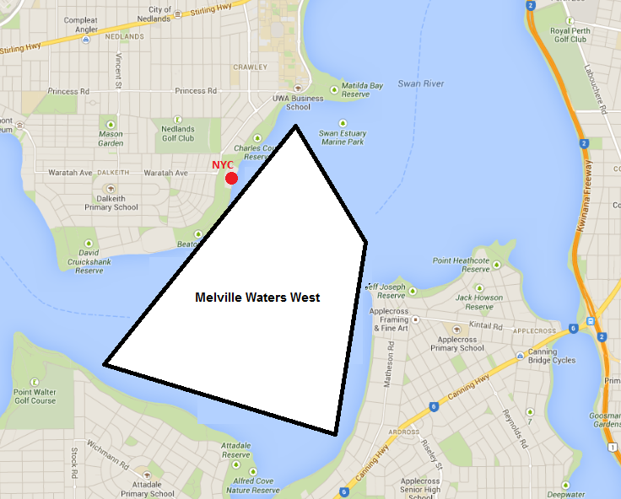

ATTACHMENT B - COURSE DIAGRAM

Start -A - C - A - B - C - A - C - Finish
Course angles are approximate.
