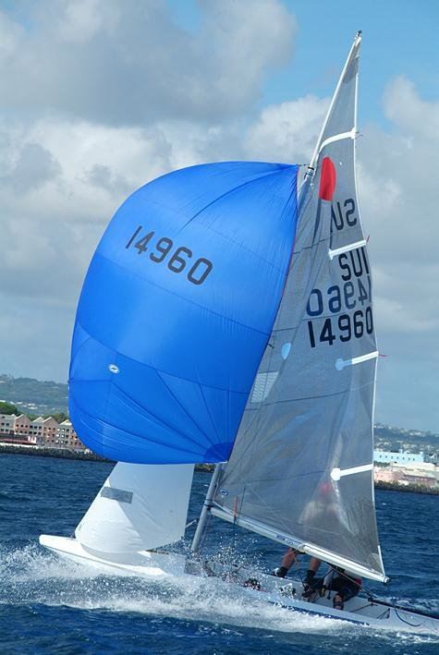
INTERNATIONAL FIREBALL
WORLD (SAILING) CHAMPIONSHIPS, 2011 – 2012

MANDURAH OFFSHORE FISHING AND SAILING CLUB,
MANDURAH, WESTERN AUSTRALIA

SPONSORSHIP TIERS ON OFFER

FIRST TIER SPONSORS ($20,000 TO $40,000 Range)

Key advertising and promotional opportunities offered:
- Company name as part of event name – ie “COMPANY NAME” International Fireball World Championships,
- Sticker space approx 1m long by 400mm high on each side of foredeck of each competing boat,
- Exposure through press releases to local and national newspapers,
- Advertising on regatta web site, MOFSC web site and Australian Fireball web site,
- Secondary exposure through press releases on UK Fireball web sites and various sailing web sites worldwide,
- Advertising on regatta face book page and twitter pages,
- Full page advert in regatta program distributed to all competitors – some 200 copies,
- Advertising both front and back of regatta T-shirts – some 350 T-shirts,
- Signage around event – posters, banners, etc,
- Advertising on event promotion posters distributed around the world,
- Logo / name on other event merchandise
- Advertising on rear deck of Association boats to be sailed at major regattas around WA over the next 18 months (say 1000mm wide by 500mm high),
- Signage at any media announcements, ie worlds launch – banners, posters, etc.

We would also invite company representatives to:
- Attend the official welcome and presentation evenings held at MOFSC,
- View some of the racing action from a support boat,
- Go for a sail in the Association boat,

INTERNATIONAL FIREBALL
WORLD (SAILING) CHAMPIONSHIPS, 2011 – 2012

MANDURAH OFFSHORE FISHING AND SAILING CLUB,
MANDURAH, WESTERN AUSTRALIA

SPONSORSHIP TIERS ON OFFER

SECOND TIER SPONSORS ($10,000 TO $20,000 Range)

Key advertising and promotional opportunities offered:
- Sticker space approx 300mm long by 80mm high on each side of boom of each competing boat,
- Exposure through press releases to local and national newspapers,
- Advertising on regatta web site, MOFSC web site and Australian Fireball web site,
- Secondary exposure through press releases on UK Fireball web sites and various sailing web sites worldwide,
- Advertising on regatta face book page and twitter pages,
- Full page advert in regatta program distributed to all competitors – some 200 copies,
- Advertising on back of regatta T-shirts – some 350 T-shirts,
- Signage around event – posters, banners, etc,
- Advertising on event promotion posters distributed around the world,
- Advertising on sides of Association boats to be sailed at major regattas around WA over the next 18 months (say 400mm wide by 200mm high),
- Signage at any media announcements, ie worlds launch – banners, posters, etc.

We would also invite company representatives to -
- Attend the official welcome and presentation evenings held at MOFSC,
- View some of the racing action from a support boat,
- Go for a sail in the Association boat,

INTERNATIONAL FIREBALL
WORLD (SAILING) CHAMPIONSHIPS, 2011 – 2012

MANDURAH OFFSHORE FISHING AND SAILING CLUB,
MANDURAH, WESTERN AUSTRALIA

SPONSORSHIP TIERS ON OFFER

THIRD TIER SPONSORS – RACE DAY SPONSOR ($2,500 TO $5,000 Range)

Key advertising and promotional opportunities offered:
- Exposure through press releases to local and national newspapers,
- Advertising on regatta web site, MOFSC web site and Australian Fireball web site,
- Secondary exposure through press releases on UK Fireball web sites and various sailing web sites worldwide,
- Advertising on regatta face book page and twitter pages,
- Half page advert in regatta program distributed to all competitors – some 200 copies,
- Advertising on back of regatta T-shirts – some 350 T-shirts,
- Minor signage around event – posters, banners, etc, (more space allocated on day sponsoring),
- Advertising on event promotion posters distributed around the world,

We would also invite company representatives to -
- Present prizes at nightly race presentations held at MOFSC,
- View some of the racing action from a support boat,

NOTE – Race day sponsorship can be done through goods in kind –

- 40 Cartons of beer from a brewery,
- Sailing gear, electrical goods, etc.

INTERNATIONAL FIREBALL
WORLD (SAILING) CHAMPIONSHIPS, 2011 – 2012

MANDURAH OFFSHORE FISHING AND SAILING CLUB,
MANDURAH, WESTERN AUSTRALIA

SPONSORSHIP TIERS ON OFFER

PRIZE SPONSORS ($1,000 TO $3,000 Range)

Key advertising and promotional opportunities offered:
- Advertising on regatta web site, MOFSC web site and Australian Fireball web site,
- Secondary exposure through press releases on UK Fireball web sites and various sailing web sites worldwide,
- Advertising on regatta face book page and twitter pages,
- Quarter page advert in regatta program distributed to all competitors – some 200 copies,
- Advertising on sleeve of regatta T-shirts – some 350 T-shirts,
- Minor signage around event on day prizes presented– posters, banners, etc,
- Advertising on event promotion posters distributed around the world,

NOTE – Prize sponsorship should be through goods in kind –

- Jib,
- Centreboard,
- Rudder Blade,
- Spinnaker Pole,
- Sailing Gear,
- Clothing,
- Electrical Goods, etc.

INTERNATIONAL FIREBALL
WORLD (SAILING) CHAMPIONSHIPS, 2011 – 2012

MANDURAH OFFSHORE FISHING AND SAILING CLUB,
MANDURAH, WESTERN AUSTRALIA

SPONSORSHIP TIERS ON OFFER

RESTAURANT SPONSORS ($500 TO $1,000 Range)

Attendance:
- Four nights available during the regatta –
      - Thursday 29th December 2011
      - Friday 30th December 2011
      - Monday 2nd January 2012
      - Friday 6th January 2012
- Promote the restaurant as the Fireball Restaurant sponsor for the evening, and encourage attendance,
- Aim to fill the restaurant for dinner, close numbers to be indicated in advance,
- Fireball people will be definable by the blue Fireball wrist band they will be wearing,

Advertising and promotional opportunities offered:
- Advertising on regatta web site, MOFSC web site and Australian Fireball web site,
- Advertising on regatta face book page and twitter pages,
- Quarter page advert in regatta program distributed to all competitors – some 200 copies,
- Advertising on sleeve of regatta T-shirts – some 350 T-shirts,
- Minor signage around event on day of function – posters, banners, etc,

In exchange:
- Restaurant to pay association $5.00 per Fireball person that is served a meal on the evening.

INTERNATIONAL FIREBALL
WORLD (SAILING) CHAMPIONSHIPS, 2011 – 2012

MANDURAH OFFSHORE FISHING AND SAILING CLUB,
MANDURAH, WESTERN AUSTRALIA

SPONSORSHIP TIERS ON OFFER

PUB SPONSORS ($500)

Attendance:
- Four nights available during the regatta –
      - Thursday 29th December 2011
      - Friday 30th December 2011
      - Monday 2nd January 2012
      - Friday 6th January 2012
- Promote the Pub as the Fireball Pub sponsor for the evening, and encourage attendance,
- Aim to fill the Pub,
- Fireball people will be definable by the blue Fireball wrist band they will be wearing,

Advertising and promotional opportunities offered:
- Advertising on regatta web site, MOFSC web site and Australian Fireball web site,
- Advertising on regatta face book page and twitter pages,
- Quarter page advert in regatta program distributed to all competitors – some 200 copies,
- Advertising on sleeve of regatta T-shirts – some 350 T-shirts,
- Minor signage around event on day of function – posters, banners, etc,

In exchange:
- Pub to offer drink special to any person wearing a blue Fireball Wrist Band,
- Pub to pay $500 fee for the right to host the event for the night.

