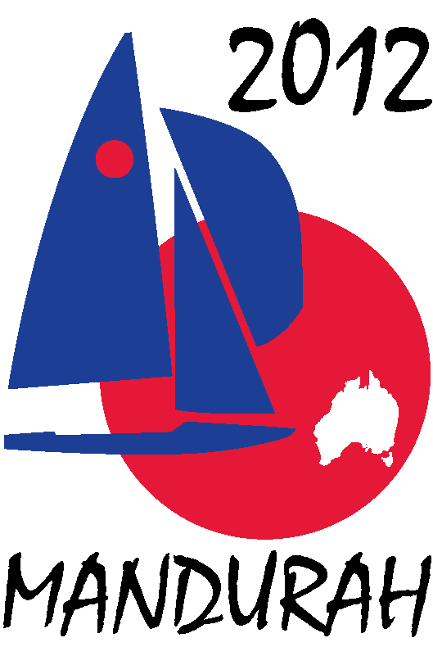
Hosted by
FIREBALL WORLDS
Hosted by Fireball International, Fireball Australia & Mandurah Offshore Fishing and Sailing Club.
Breakwater Parade, Mandurah, Western Australia, 6210 PO Box 219, Mandurah WA. 6210
Contacts – Ben Schulz +61 (0) 400 991 606 ben@schulz.com.au Kevin Luff +61 (0) 407 428 221 lofflot2@bigpond.com

BOUY SPONSORSHIP PACKAGES
A Fireball race involves sailing around either a triangular or trapezoid shaped course.
Each corner of the course is defined by a marker buoy anchored in position.
These marker buoys are 3 or 4 sided pyramids in shape with approximate dimensions of 1.5m wide and 1.5m high. This provides 3 or 4 large faces on the buoys on which advertising can be placed.
As a lot of the action in the race takes place at the rounding of the buoys, the buoys feature a lot in any media coverage including television, video and photography.

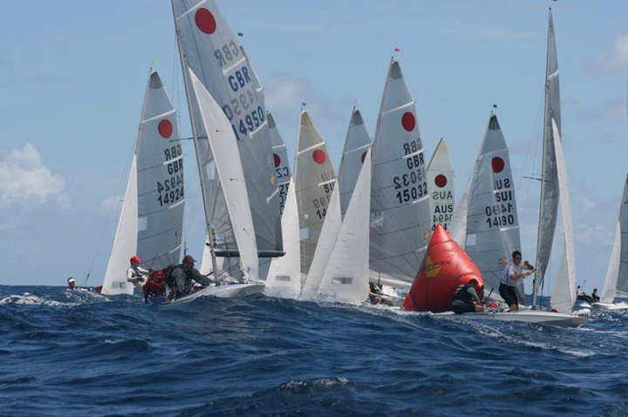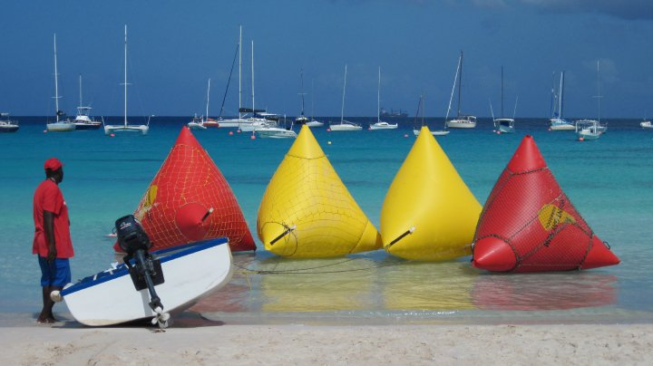

As a buoy sponsor for the regatta you will be provided with the opportunity to advertise on the buoys.
Including the start and finish buoys, eight buoys are used in a race.

Buoy Packages -
A full buoy sponsorship – advertising on all eight buoys is offered for $5,000.00.
A half buoy sponsorship – advertising on four buoys is offered for $2,500.00.
Individual buoy sponsorship is available for $1,000.00
(Amount above does not include advertising to be supplied by sponsor)

For a full and half buoy sponsorship the following additional advertising and promotional opportunities can be offered:
- Exposure through press releases to local and national newspapers,
- Advertising on regatta web site, MOFSC web site and Australian Fireball web site,
- Secondary exposure through press releases on UK Fireball web sites and various sailing web sites worldwide,
- Advertising on regatta face book page and twitter pages,
- Full page advert in regatta program distributed to all competitors – some 200 copies, (half page ad for half sponsors)
- Signage around event – posters, banners, etc,

Under the full buoy sponsorship we would also invite company representatives to -
- Attend the official welcome and presentation evenings held at MOFSC,
- View some of the racing action from a support boat,
- Go for a sail in the Association boat

If you would like more information please contact Ben Schulz or Kevin Luff or
View our web sites - www.fireball-worlds.com www.fireball Australia.org www.mofsc.com.au

