
Hosted by
FIREBALL WORLDS
Hosted by Fireball International, Fireball Australia & Mandurah Offshore Fishing and Sailing Club.
Breakwater Parade, Mandurah, Western Australia, 6210 PO Box 219, Mandurah WA. 6210
Contacts – Ben Schulz +61 (0) 400 991 606 ben@schulz.com.au Kevin Luff +61 (0) 407 428 221 lofflot2@bigpond.com

FUEL SPONSORSHIP PACKAGES
To run a Fireball race a safety boat is require for every ten entrants.
At the end of the day competitor safety is the number one priority.
For the 2012 Fireball Worlds 10 safety boats will be used.
These boats will be a mixture of 15 – 20 foot inflatable ribs and 16 – 30 foot standard motor boats.
These boats are close to the action and as a result appear in a lot of the television, video and photography.
There will be 3 days racing in the Australian Championships / International Regatta (Preworlds) and 5 days racing in the World Championships (Worlds).

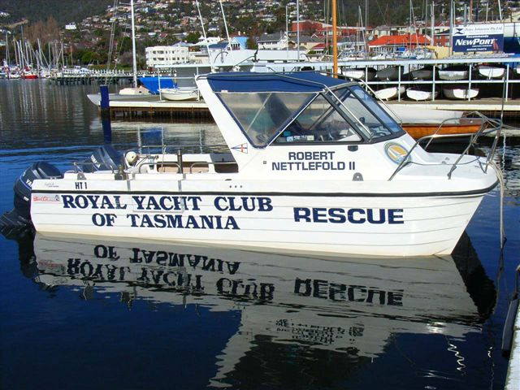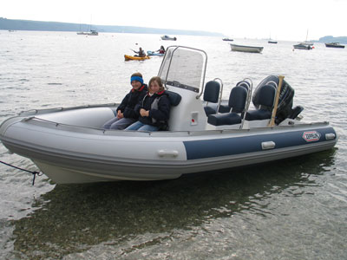

As a fuel sponsor for the regatta you will be provided with the opportunity to advertise on the foredeck of the safety boats.

Fuel Sponsorship Packages -
Full event sponsorship – fuel provided for 8 days racing to the value of $5,000.00.
Pre Worlds sponsorship – fuel provided for 3 days racing to the value of $1,875.00.
Worlds sponsorship – fuel provided for 3 days racing to the value of $1,875.00.
Race day fuel sponsorship – fuel provided for 1 days racing to the value of $625.00
(Amount above does not include advertising to be supplied by sponsor)

In additional to the advertising on the boats themselves safety boat sponsors will be offered:
- Exposure through press releases to local and national newspapers,
- Advertising on regatta web site, MOFSC web site and Australian Fireball web site,
- Secondary exposure through press releases on UK Fireball web sites and various sailing web sites worldwide,
- Advertising on regatta face book page and twitter pages,
- Advert in regatta program distributed to all competitors – some 200 copies,
- Signage around event – posters, banners, etc,

(The extent of this advertising will be determined by the package adopted)

If you would like more information please contact Ben Schulz or Kevin Luff or
View our web sites - www.fireball-worlds.com www.fireball Australia.org www.mofsc.com.au

