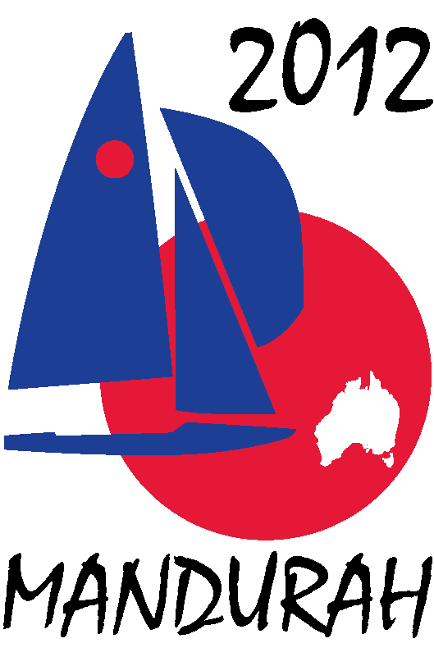
Hosted by
FIREBALL WORLDS
Hosted by Fireball International, Fireball Australia & Mandurah Offshore Fishing and Sailing Club.
Breakwater Parade, Mandurah, Western Australia, 6210 PO Box 219, Mandurah WA. 6210
Contacts – Ben Schulz +61 (0) 400 991 606 ben@schulz.com.au Kevin Luff +61 (0) 407 428 221 lofflot2@bigpond.com

30 September 2010

Address1
Address 2
Address 3

Fireball Sailing World Championship Sponsorship Opportunities

Dear Sir or Madam,

The 2012, 50th anniversary Fireball Sailing World Championships are coming to Australia and will be hosted by the Mandurah Offshore Fishing and Sailing Club, Mandurah Western Australia from 27th December 2011 to January 7th 2012. Event organisers are seeking sponsors to support the event and would like to offer your organisation the opportunity to be part of this first World Championships to be held in Mandurah.
The Fireball World Championships is one of the premier world sailing championships with competitors travelling from countries across the globe.
The event always attracts significant coverage in local, national and international news and sailing media channels wherever it is held.
Recent events have been held in Bridgetown Barbados 2010, La Rochelle France 2009 and Pattaya Thailand 2008, all attracting fleets of over 75 boats

What is a Fireball?
The Fireball is a high performance two person sailing dinghy offering exciting sailing, intense competition and a great social life off the water. It has wide appeal as it is simple to build reasonably priced and not too demanding to sail.
The Fireball is sailed at many clubs across Australia and around the world. Launched in 1962 in the UK more than 15,000 have been built, National, European and World Championships are held annually and it is recognized as one of the leading dinghy fleets worldwide.

Who sails a Fireball?
Fireball sailors range in age from teenagers through to 70+ years old and have diverse backgrounds, but all have the same things in common, a love of sailing, a competitive spirit and enjoy the great social activities these events offer. The competition ranges from the highly committed “semi-professional” top end through to the occasional competitive but willing sailors at the back of the fleet. To attend an event such as this involves significant investment of time and money on the competitor’s behalf, all pay their own fares, entry and boat shipping costs.
Through sponsorship the organisers hope to reward this commitment with a first class event both on and off the water.

What will the event entail?
The regatta consists of two separate championships; the first will be an international regatta incorporating the Australian championships held over 3 days with 6 races. The second will be the 2012 world championships held over 5 days with 10 scheduled races.
It is expected that over 80 boats will attend the event with up to 40 Australian teams and the remainder international entries from over a dozen countries. In addition to the competitors the event expects to attract at least 200 supporters, friends and family members.
For corporate sponsors a range of packages are on offer. These include:
- Safety boat sponsorship
- Individual race day sponsorship
- Marker buoy sponsorship
- Business supporter packages
More detailed information on each of the packages can be found in the following pages. Should you have any questions or would like to discuss being an event sponsor please contact either Ben Schulz IFAA Secretary or Kevin Luff Regatta Chairman.
Whilst these are our main corporate packages the organisers invite offers of product or logistics support should your organisation wish to support the event in such a way.
One of our representatives will be in contact in the coming weeks to discuss the packages with you and answer any questions you may have.

Regards

Ben Schulz
IFAA Secretary

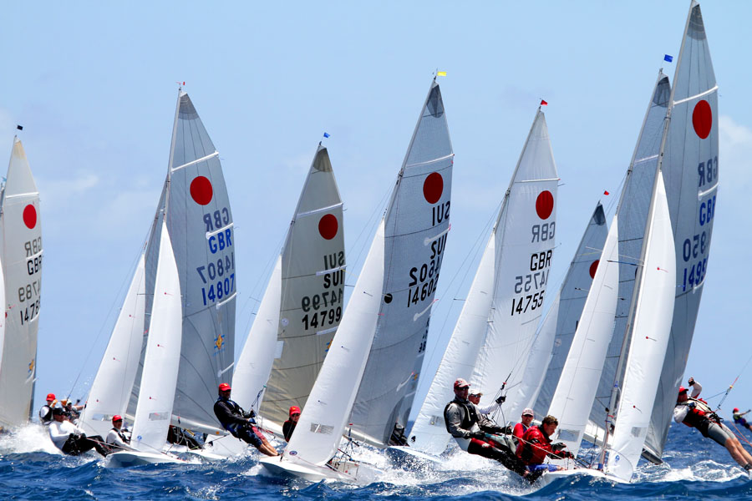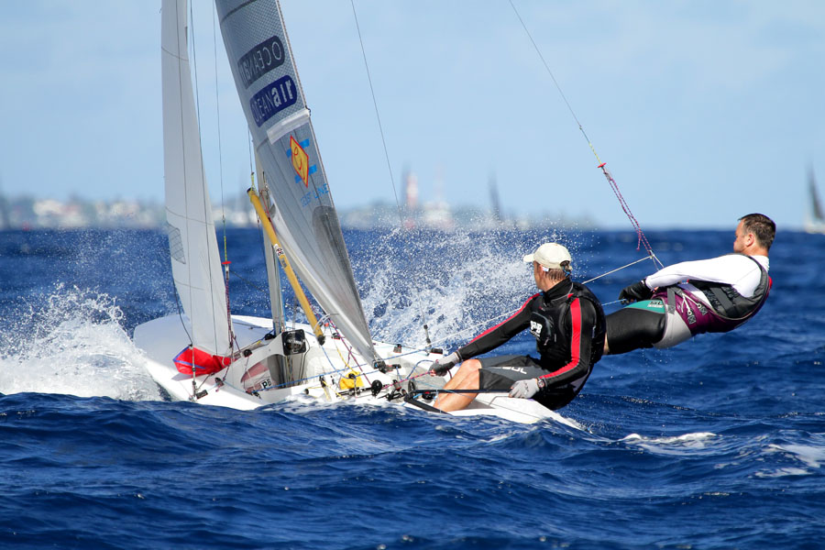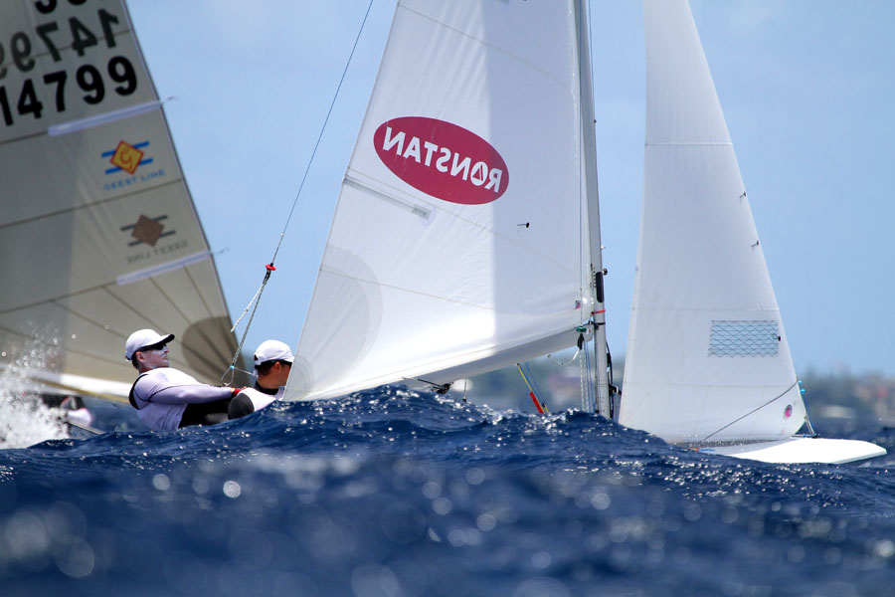
Hosted by Fireball International, Fireball Australia & Mandurah Offshore Fishing and Sailing Club.
Breakwater Parade, Mandurah, Western Australia, 6210 PO Box 219, Mandurah WA. 6210
Contacts – Ben Schulz +61 (0) 400 991 606 ben@schulz.com.au Kevin Luff +61 (0) 407 428 221 lofflot2@bigpond.com

Images from Barbados 2010 World Championships

