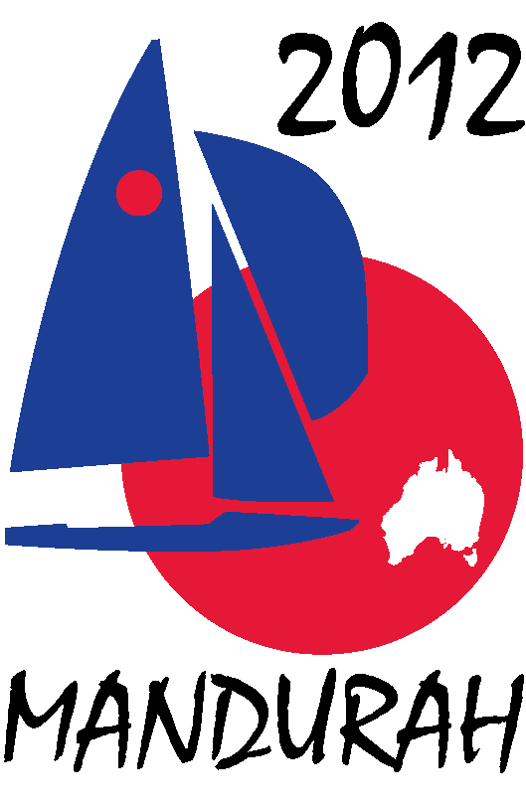
Hosted by
FIREBALL WORLDS
Hosted by Fireball International, Fireball Australia & Mandurah Offshore Fishing and Sailing Club.
Breakwater Parade, Mandurah, Western Australia, 6210 PO Box 219, Mandurah WA. 6210
Contacts – Ben Schulz +61 (0) 400 991 606 ben@schulz.com.au Kevin Luff +61 (0) 407 428 221 lufflot2@bigpond.com

EVENT NAMING RIGHTS SPONSORSHIP
The 2012 Fireball Worlds are made up of two regattas.
The Australian Championships and International Regatta run from the 27th December to 31st December 2011. They are made up of six races over three days.
The World Championships run from the 2nd January to 7th January 2012. They are made up of ten races over five days.
Exclusive naming rights sponsorship is on offer for the entire event, in return for an investment of $10,000
The sponsors business will benefit from the following in return.
- Exclusive naming rights for the event.
- Media coverage, local and state broadcast media and international sailing media.
- Exclusive sponsor supplied advertising on the competitors boats
- Advertising on regatta, MOFSC, and Australian Fireball web sites.
- Secondary exposure through press releases on UK Fireball web sites and various sailing web sites worldwide.
- Advertising on regatta face book page and twitter pages.
- Large signage around the club house and boat storage yard.
- Full page advert and write up in the event program issued to all competitors.
- Event clothing advertising with your business logo or slogan.
- Invitation for business representatives to attend the opening and presentation evenings.
- Invitation for business representatives to watch the racing from a spectator boat.
- Exposure to approximately 3000 club members.
- YouTube coverage (see the BBC World News interview recorded at the Barbados event).
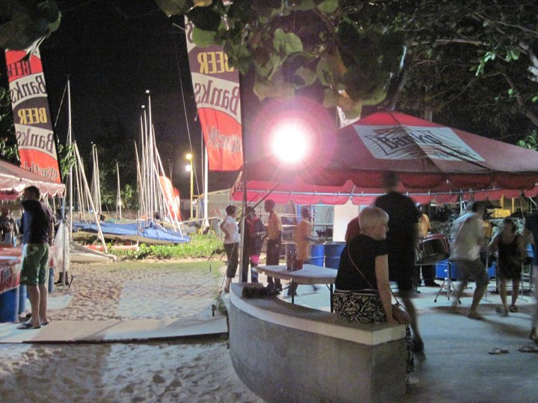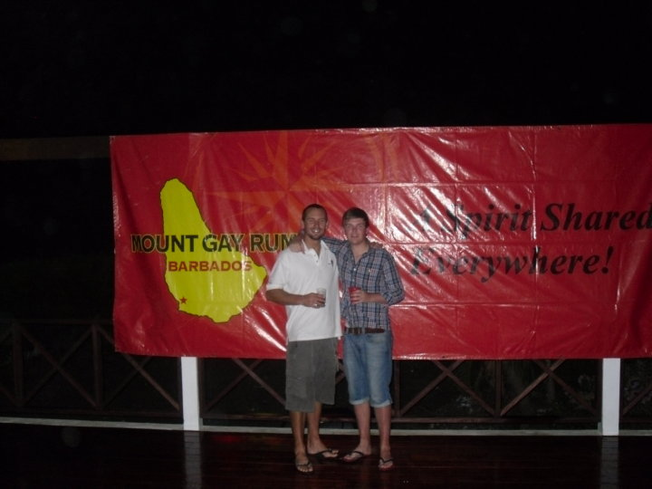
Sponsorship signage from Barbados 2010
The event will be hosted by Mandurah Offshore Fishing and Sailing club and is supported by Mandurah council and the WA Government. If you would like more information please contact Ben Schulz or Kevin Luff (details below). Additional event information can be found on the following web sites.
www.fireball-worlds.com – www.fireballaustralia.org – www.mofsc.com.au

