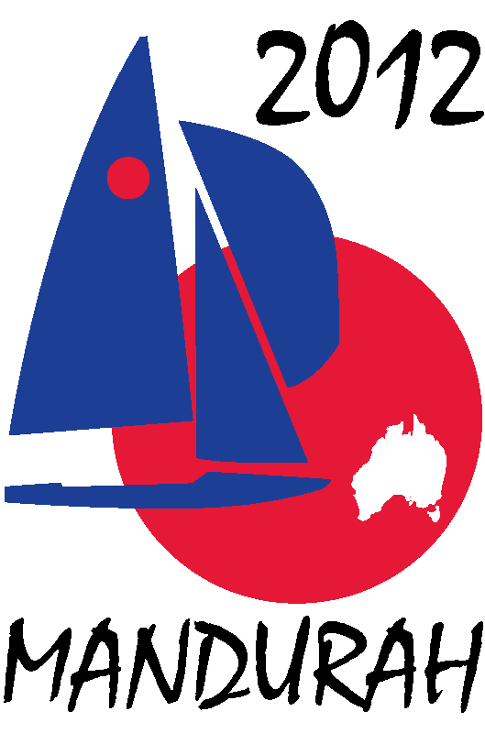
Hosted by
FIREBALL WORLDS
Hosted by Fireball International, Fireball Australia & Mandurah Offshore Fishing and Sailing Club.
Breakwater Parade, Mandurah, Western Australia, 6210 PO Box 219, Mandurah WA. 6210
Contacts – Ben Schulz +61 (0) 400 991 606 ben@schulz.com.au Kevin Luff +61 (0) 407 428 221 lofflot2@bigpond.com

6 May 2011

Tony Lynn
Ronstan Australia

Dear Tony,

The 2012 Fireball World Championships are being held from 27th December 2011 to 7th January 2012 in Mandurah, Western Australia. We are expecting over 80 boats, 160 sailors, 80 volunteers, plus families and friends to attend.

We wish to invite your participation in this event as a Prize Sponsor.

As a prize sponsor you would be offered advertising and promotional opportunities including:
- Advertising on regatta web site, MOFSC web site and Australian Fireball web site,
- Secondary exposure through press releases on UK Fireball web sites and various sailing web sites worldwide,
- Advertising on regatta face book page and twitter pages,
- Quarter page advert in regatta program distributed to all competitors – some 200 copies,
- Minor signage around event on day prizes presented– posters, banners, etc,
- Advertising on event promotion posters distributed around the world,

In exchange we ask that Ronstan Australia donate product to the value of $1000.00 or a voucher of equivalent value as a prize to be given out as a daily heat prize during the regatta.

We hope you find this offer beneficial and look forward to your involvement with the championships. In the coming weeks, one of our organizing committee will be in contact to discuss the proposal further.

Sincerely,

Ben Schulz
Regatta Secretary

