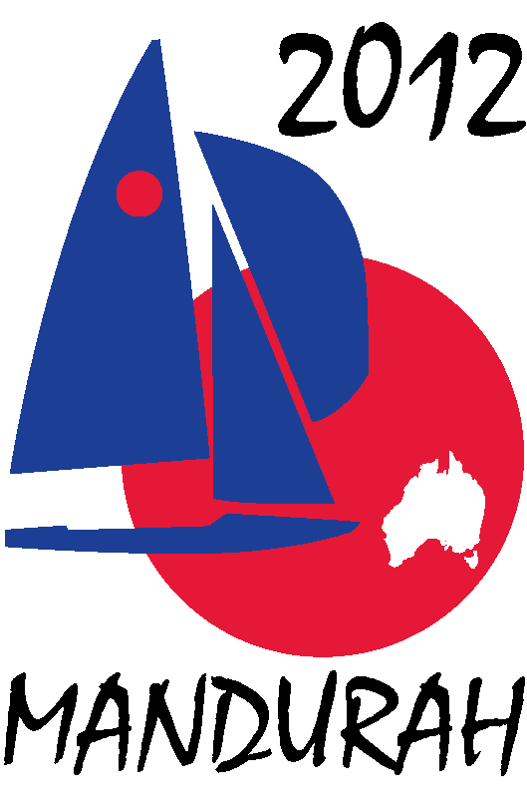
Hosted by
FIREBALL WORLDS
Hosted by Fireball International, Fireball Australia & Mandurah Offshore Fishing and Sailing Club.
Breakwater Parade, Mandurah, Western Australia, 6210 PO Box 219, Mandurah WA. 6210
Contacts – Ben Schulz +61 (0) 400 991 606 ben@schulz.com.au Kevin Luff +61 (0) 407 428 221 lofflot2@bigpond.com

RACE DAY SPONSORSHIP PACKAGES

The 2012 Fireball Worlds are made up of two regattas.
The Australian Championships and International Regatta run from the 27th December to 31st December 2011. They are made up of six races over three days.
The World Championships run from the 2nd January to 7th January 2012. They are made up of ten races over five days.
This provides an opportunity to become a Race Day Sponsor for one of either the three days of the first regatta or one of the five days of the second regatta.
As a Race Day Sponsor your business will benefit from:
- Race naming rights for the day,
- Large signage around the club house and boat storage yard,
- Invitation for business representatives to present prizes for the day,
- Invitation for business representatives to watch the racing from a spectator boat,

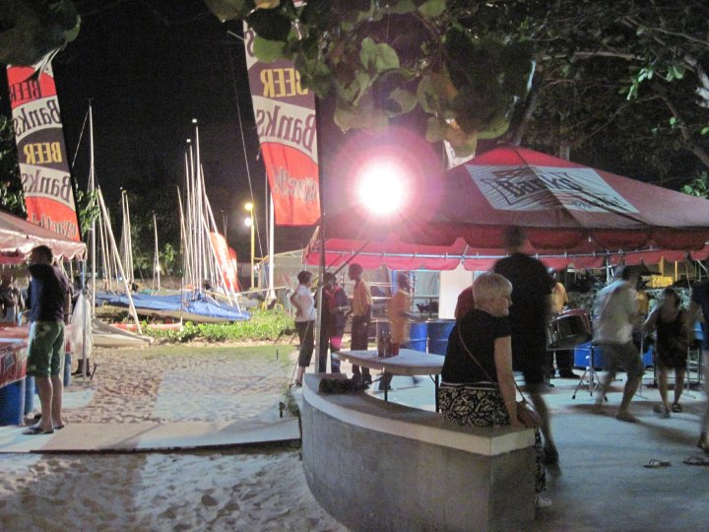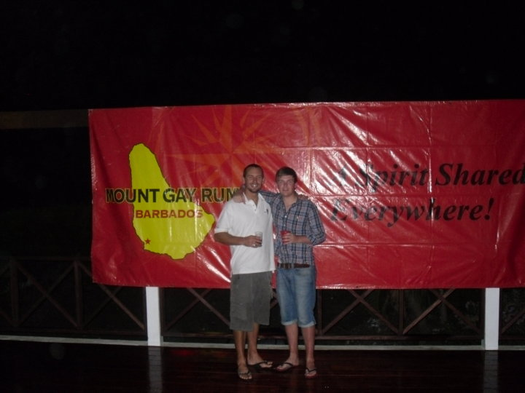
Race Day Packages –
Australian Champs / International Regatta - $1,000.00
World Championships - $1,500.00

In addition to the advertising on the day we can also offer:
- Exposure through press releases to local and national newspapers,
- Advertising on regatta web site, MOFSC web site and Australian Fireball web site,
- Secondary exposure through press releases on UK Fireball web sites and various sailing web sites worldwide,
- Advertising on regatta face book page and twitter pages,
- Half page advert in regatta program distributed to all competitors – some 200 copies,
- Minor signage around event – posters, banners, etc, (more space allocated on day sponsoring),

If you would like more information please contact Ben Schulz or Kevin Luff or
View our web sites - www.fireball-worlds.com www.fireball Australia.org www.mofsc.com.au

