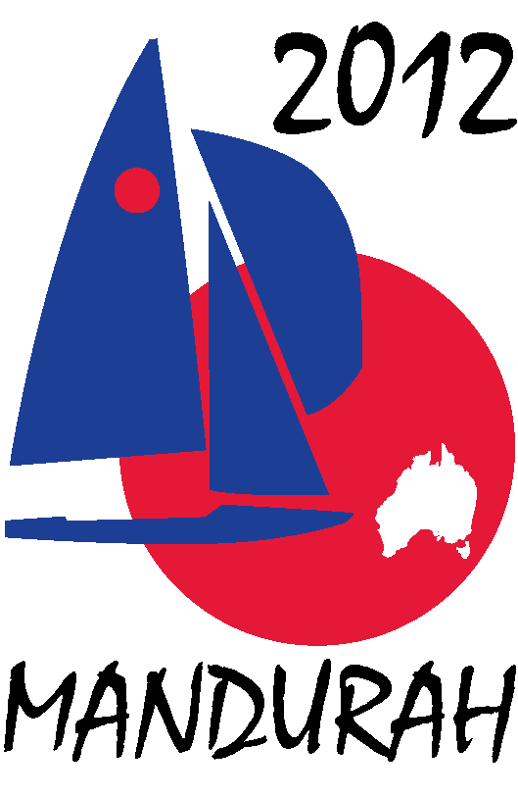
Hosted by
FIREBALL WORLDS
Hosted by Fireball International, Fireball Australia & Mandurah Offshore Fishing and Sailing Club.
Breakwater Parade, Mandurah, Western Australia, 6210 PO Box 219, Mandurah WA. 6210
Contacts – Ben Schulz +61 (0) 400 991 606 ben@schulz.com.au Kevin Luff +61 (0) 407 428 221 lofflot2@bigpond.com

30 September 2010

Address1
Address 2
Address 3

Fireball Sailing World Championship 2012

Dear Sir or Madam,

The 2012, 50th anniversary Fireball Sailing World Championships are coming to Australia and will be hosted by the Mandurah Offshore Fishing and Sailing Club, Mandurah Western Australia from 27th December 2011 to January 7th 2012. Event organisers are seeking sponsors to support the event and would like to offer your organisation the opportunity to be part of this first World Championships to be held in Mandurah.
The Fireball World Championships is one of the premier world sailing championships with competitors travelling from countries across the globe.
The event always attracts significant coverage in local, national and international news and sailing media channels wherever it is held.
Recent events have been held in Bridgetown Barbados 2010, La Rochelle France 2009 and Pattaya Thailand 2008, all attracting fleets of over 75 boats

What is a Fireball?
The Fireball is a high performance two person sailing dinghy offering exciting sailing, intense competition and a great social life off the water. It has wide appeal as it is simple to build reasonably priced and not too demanding to sail.
The Fireball is sailed at many clubs across Australia and around the world. Launched in 1962 in the UK more than 15,000 have been built, National, European and World Championships are held annually and it is recognized as one of the leading dinghy fleets worldwide.

Who sails a Fireball?
Fireball sailors range in age from teenagers through to 70+ years old and have diverse backgrounds, but all have the same things in common, a love of sailing, a competitive spirit and enjoy the great social activities these events offer. The competition ranges from the highly committed “semi-professional” top end through to the occasional competitive but willing sailors at the back of the fleet. To attend an event such as this involves significant investment of time and money on the competitor’s behalf, all pay their own fares, entry and boat shipping costs.
Through sponsorship the organisers hope to reward this commitment with a first class event both on and off the water.

What will the event entail?
The regatta consists of two separate championships; the first will be an international regatta incorporating the Australian championships held over 3 days with 6 races. The second will be the 2012 world championships held over 5 days with 10 scheduled races.
It is expected that over 80 boats will attend the event with up to 40 Australian teams and the remainder international entries from over a dozen countries. In addition to the competitors the event expects to attract at least 200 supporters, friends and family members.

How can you be involved?
The event organising committee wishes to invite your restaurant to become involved with the regatta as a restaurant sponsor.
At past regattas we have successfully teamed up with restaurants to organise a dinner evening where sailors, friends and family attend for a meal and a good social evening.
In exchange for locking in our patronage - normally between 100 and 150 people – we ask that the restaurant donate to the association $5.00 from each meal served. In this way you benefit from having our patronage and we benefit through your financial support which would then be used to meet the costs of holding the regatta such as fuel for safety craft, trophies and venue hire.
At this stage we have three dates available during the regatta; they are Thursday 29th December 2011, Monday 2nd January 2012 and Friday 6th January 2012.
As well as our patronage, we can offer a half page advertisement in our event program that is distributed to all competitors at the commencement of the regatta, and an opportunity for you to become involved with the regatta by coming down, seeing the boats, meeting the competitors and maybe even watching some racing from one of the spectator boats.
Should you have any questions or would like to discuss being involved further please contact either Ben Schulz IFAA Secretary or Kevin Luff Regatta Chairman otherwise one of our representatives will be in contact in the coming weeks to discuss the packages with you and answer any questions you may have.
Regards

Ben Schulz
IFAA Secretary

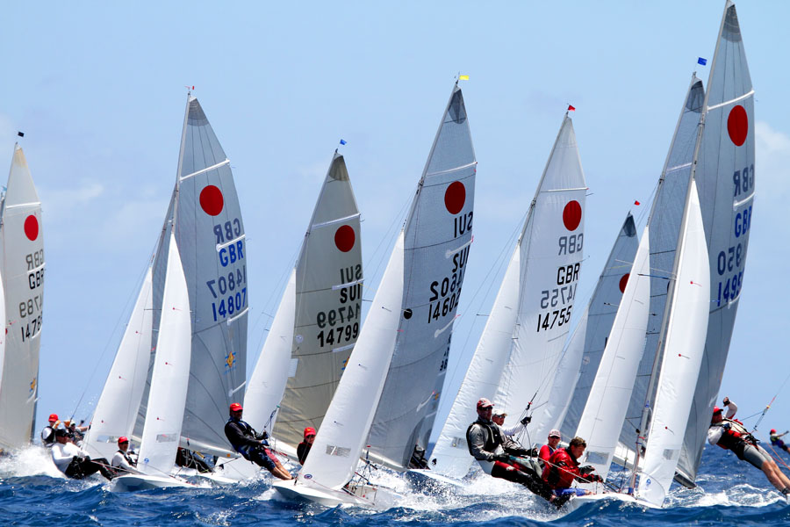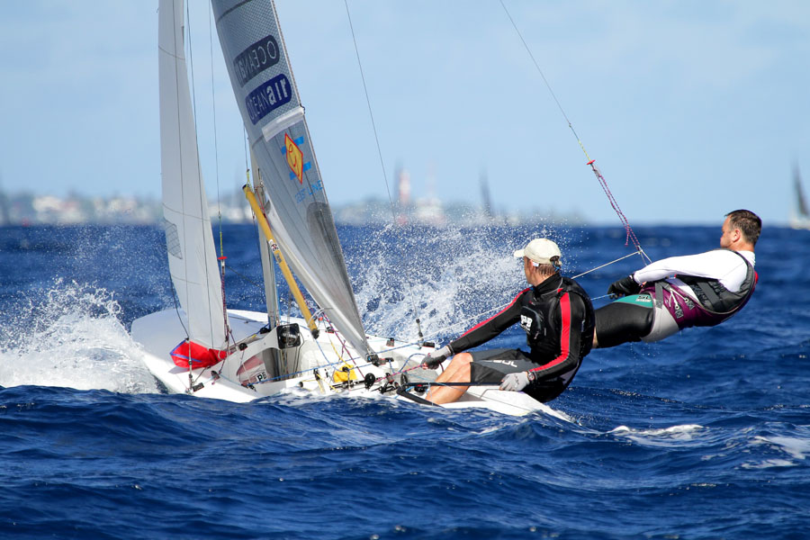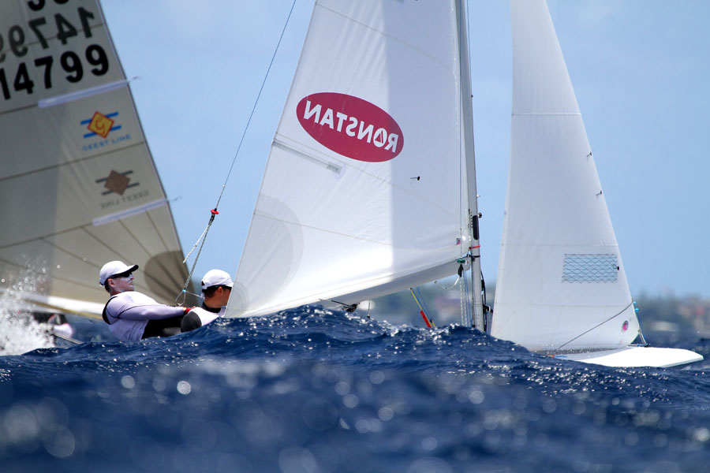
Hosted by Fireball International, Fireball Australia & Mandurah Offshore Fishing and Sailing Club.
Breakwater Parade, Mandurah, Western Australia, 6210 PO Box 219, Mandurah WA. 6210
Contacts – Ben Schulz +61 (0) 400 991 606 ben@schulz.com.au Kevin Luff +61 (0) 407 428 221 lofflot2@bigpond.com

Images from Barbados 2010 World Championships

