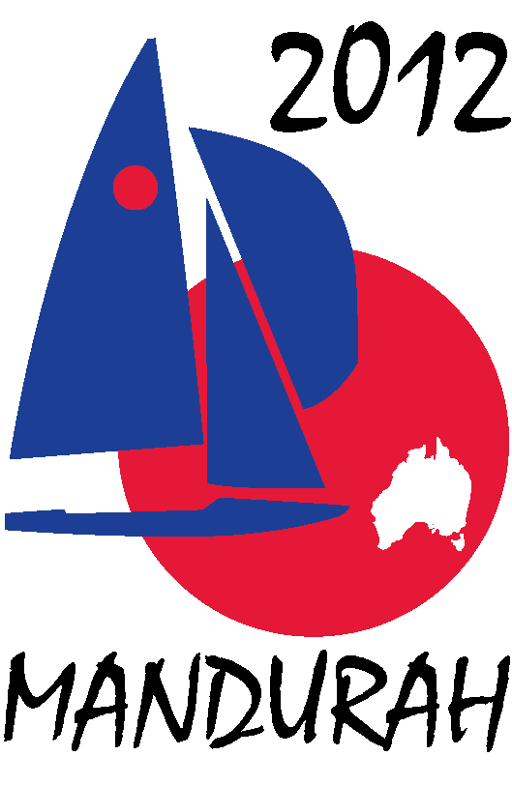
Hosted by
FIREBALL WORLDS
Hosted by Fireball International, Fireball Australia & Mandurah Offshore Fishing and Sailing Club.
Breakwater Parade, Mandurah, Western Australia, 6210 PO Box 219, Mandurah WA. 6210
Contacts – Ben Schulz +61 (0) 400 991 606 ben@schulz.com.au Kevin Luff +61 (0) 407 428 221 lofflot2@bigpond.com

SAFETY BOAT SPONSORSHIP PACKAGES

To run a Fireball race a safety boat is required for every ten entrants.
At the end of the day competitor safety is the number one priority.
For the 2012 Fireball Worlds 10 safety boats will be used.
These boats will be a mixture of 15 – 20 foot inflatable ribs and 16 – 30 foot standard motor boats.
These boats are close to the action and as a result appear in a lot of the television, video and photography.

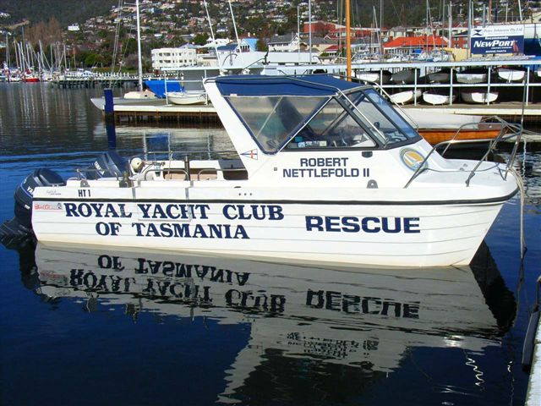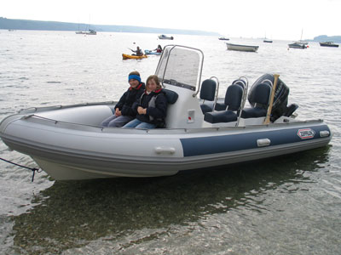

As a safety boat sponsor for the regatta you will be provided with the opportunity to advertise on the sides and foredeck of one of the safety boats.

Safety Boat Packages -
Hard side boat sponsorship – larger sides for advertising $1,500.00.
Rib sponsorship – smaller sides for advertising $1,000.00.
(Amount above does not include advertising to be supplied by sponsor)

In additional to the advertising on the boats themselves safety boat sponsors will be offered:
- Exposure through press releases to local and national newspapers,
- Advertising on regatta web site, MOFSC web site and Australian Fireball web site,
- Secondary exposure through press releases on UK Fireball web sites and various sailing web sites worldwide,
- Advertising on regatta face book page and twitter pages,
- Quarter page advert in regatta program distributed to all competitors – some 200 copies,
- Minor signage around event – posters, banners, etc,

If you would like more information please contact Ben Schulz or Kevin Luff Additional event information can be found on the following web sites.

www.fireball-worlds.com – www.fireballaustralia.org – www.mofsc.com.au

