FIREBALL WORLD SAILING CHAMPIONSHIPS 2012
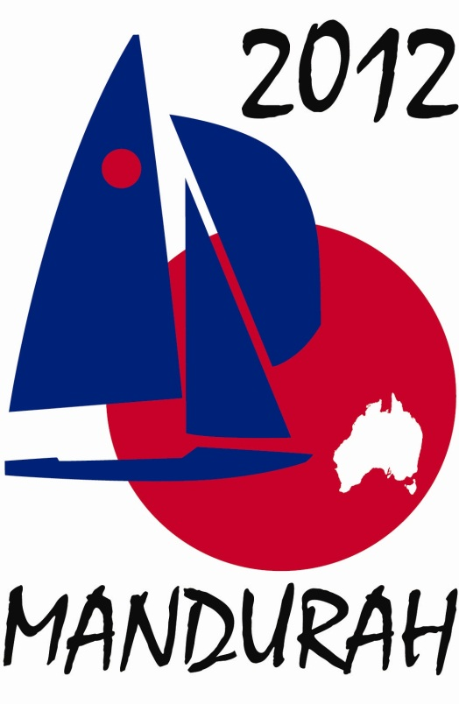

Final Event Report

Table of Contents

Event Description 3
Event Management, Planning and Objectives 4
Visitor/Attendance Numbers 6
Economic Impact 8
Marketing and Promotions 9
Media Impact 10
Sponsorship 11
Community Support 12
Attendance 13
Signage 17
Event Budget 17
Evaluation 17
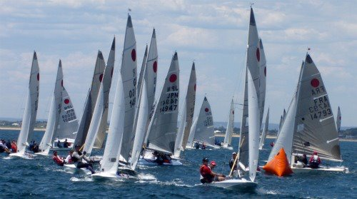

Event Description
The International Fireball 2012 World (Sailing) Championship were held at Mandurah Offshore Fishing and Sailing Club (MOFSC) from 27th December 2011 to 7th January 2012. MOFSC was the event host with Fireball International and Fireball Australia assisting with the organization.
The event consisted of registration and measuring on the 27th and 28th December 2011, followed by two regattas, the Pre-world Championship incorporating the Australian Championship from 29th December 2011 to 31st December 2011 where 4 of the scheduled 6 races were sailed, then the World Championship from 2nd January 2012 to 7th January 2012 where all 10 scheduled races were completed.
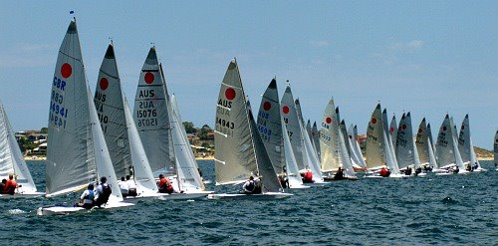
64 boats took part in the event –
- 39 from Australia
- 7 from United Kingdom,
- 5 from Switzerland,
- 1 from France,
- 2 from Czech Republic,
- 6 from Japan and
- 4 from Canada.

Apart from the racing out on Comet Bay, there was a strong social program. The event opened with a civic reception hosted by Mayor Patti Creevey. Next was the Pre-worlds Presentation Dinner and New Years Eve Show, a “50 Years of Fireball” celebratory dinner and finally the official Worlds Prize Giving Dinner to close the event. In between the official functions there were nightly happy hours at the club with presentations of prizes for the days racing.
The weather was reasonably kind although a bit out of character for December – January. During the Pre-worlds one day’s racing was cut short by lack of wind then the next lost due to excessive wind. The competitors were unfazed as that is all a part of sailing. The winds settled down for the World Championships providing some exciting racing. The eventual winner only being decided on the last lap of the final race.
Off the water the competitor’s families were given the opportunity to explore the local area using supplied mini bus transport, allowing them to take in all the local area had to offer. The abundant supply of restaurants, cafes and shops meant that there was plenty of options and all visitors commented on what a great location Mandurah was to holiday and race.

Event Management, Planning and Objectives
The events vision/purpose was –
Provide Fireball International with their 2012 World Championships.
This was successfully achieved – 4 races sailed in the Pre World Championships and all 10 races sailed in the World Championships.
Provide sailors with safe and well managed races.
The race management at the event was rated by the competitors as some of the best that they had seen. Robin Olsen, the Principal Race Officer and his team did an exceptional job in some trying conditions. A lot of the success can be put down to the experience of the team assembled. Mike Rogers, a previous winner of the Fireball World Championships and 5 time Principal Race Officer at Fireball World Championships provided Robin with vast insight into how Fireball Racing needed to be conducted. Mick Bowley again a National Race Officer and course layer at multiple world championship helped set the courses. These three were assisted by many able volunteers with many years’ experience.
Provide competitors, family, friends and supporters with a venue that meets their range of needs during their stay.
The club provided all that the sailors could ask for and more. All of the basic items required for a championship were provided at the highest quality – adequate storage, wash down facilities, showers and change rooms, safe launching and large club house. It was the little things however that had sailors stating that the event was one of the best ever. The food was a huge hit with International visitors blown away by the local sea food. The free mini bus meant that getting around the area was really easy. The largest positive feedback came from the families who had never been to a more children friendly regatta – keep the kids happy and the parents are ecstatic rang true.

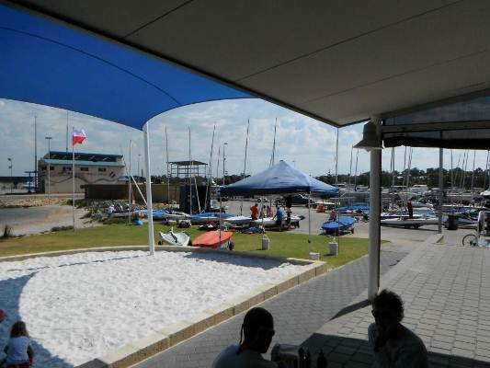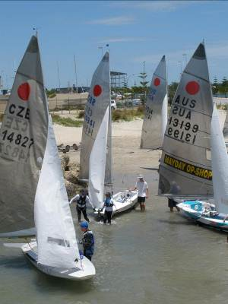
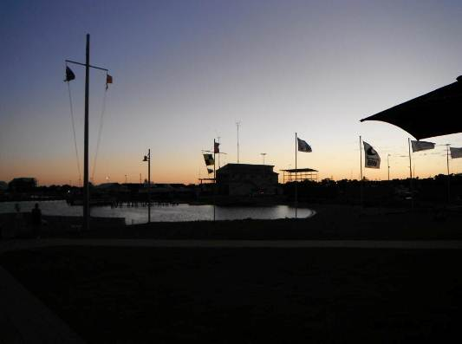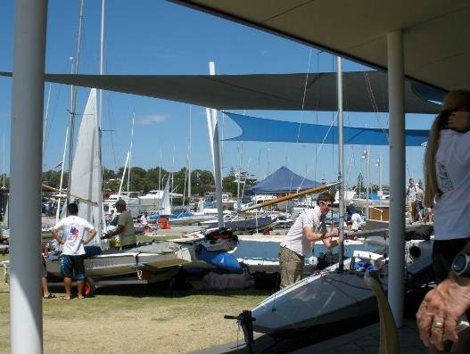
Provide excellent off water activities for both sailors and non sailors to showcase what WA has to offer.
The four main social dinners were hugely popular. Great food, great atmosphere, etc.
After sailing each day a free drink and a snack was given to every person. This set the scene for the night encouraging people to stay, have a few drinks and a meal and interact. The nightly presentation of prizes included lucky draws for sailors, non-sailors and volunteers encouraging them to be on the premises to win a prize.

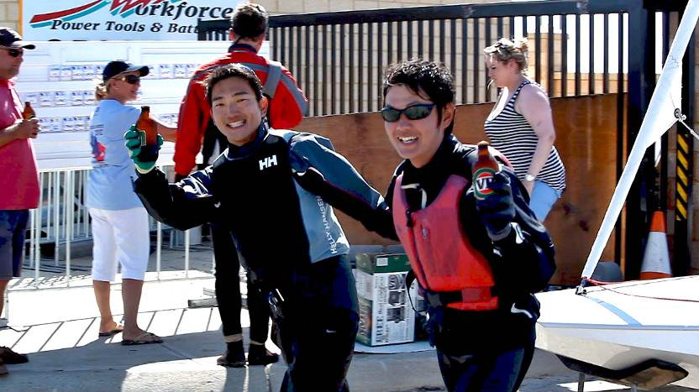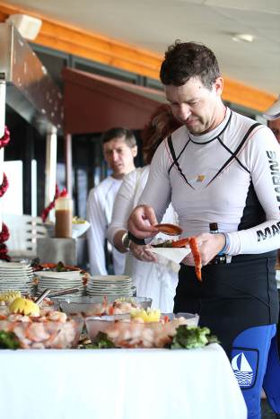

The daily planned excursions for non-sailors were greatly appreciated. Attendance started off a bit low because people had never seen this before and didn’t know what to expect but as word spread the numbers climbed dramatically.
One note here of where there was room for improvement was the need to have someone who was tourism savvy manning a desk full time to help with enquiry. This is one area where work with the Visitor Centre could be improved so there was better information on how to book on tours, clearer information on what is available. A volunteer does a good job but they don’t know all the options available.
Provide MOFSC with the opportunity to develop expertise in hosting World Championships to enable them to host future national and international regattas for other fleets.
The regatta provided MOFSC personnel with a wealth of experience on how to run an International regatta. On the water there was the experience of running top level racing. Off the water the club gained a greater appreciation of what is required to firstly put on a regatta and secondly what the next step is to making it a great regatta. This experience will make planning for future regattas much easier and allow the club to be more prepared.
All members of the organizing committee put in an enormous amount of work to make the event a success. The strength of the committee was its flexibility and ability to make necessary changes during the event to ensure that everything ran smoothly.
Having a committee that knew what each person’s responsibilities were made life much simpler.
The organizing committee consisted of the following people:
- Kevin Luff MOFSC Chairman Public Relations, Prizegiving
- Sue Olsen MOFSC On Shore Social Functions, Results, Admin
- Robin Olsen MOFSC On Water Race Management, Volunteers
- Tim Donkin MOFSC On Shore Club Manager
- Peter Crossley IFAA Promotion Web Site, Printing, Marketing,
- Ben Schulz IFAA Secretary Finance, Sponsorship, Trophies
- Andrew Davies FI Technical Rules, Entries, Jury

To run the event 50 volunteers were utilized each day on top of the 30 paid staff at the club.
Many thanks to all those who put their hands up and helped out.

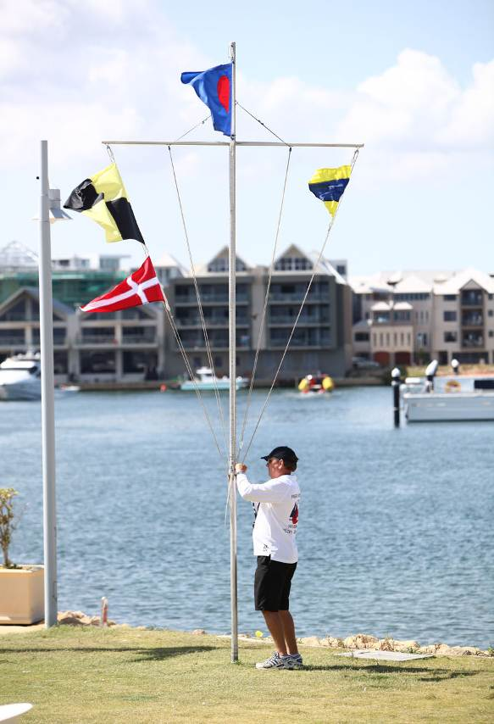
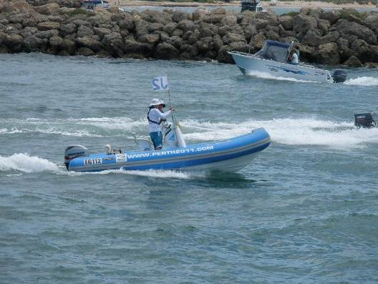

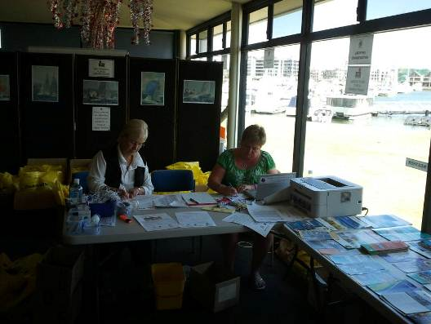
Visitor/Attendance Numbers
Estimated attendance number at time of grant application -
Type of visitors | Estimated Visitor #’s (from application)
WA visitors – within local area | 3080
WA visitors – non local area | 560
Interstate visitors | 450
International visitors | 250
Total visitors | 4340

Daily attendance numbers were as follows –

Date | Event | Sailors | Volunteers | Non Sailors | Public | Total
26 Dec 2011 | Unpacking | 76 | 18 | 57 | 65 | 206
27 Dec 2011 | Registration/ Measuring | 128 | 60 | 80 | 90 | 358
27 Dec 2011 | Publicity sail up river | 40 | 8 | 20 | 1500 | 1568
28 Dec 2011 | Registration / Measuring | 128 | 60 | 70 | 120 | 378
28 Dec 2011 | Welcome Night | 128 | 50 | 142 | 85 | 405
29 Dec 2011 | Pre Worlds Ht 1 including spectator boats | 128 | 56 | 55 | 70 | 309
29 Dec 2011 | Nightly Presentation | 128 | 40 | 110 | 180 | 458
30 Dec 2011 | Pre Worlds – Sailing including spectator boats | 128 | 56 | 48 | 80 | 312
30 Dec 2011 | Nightly Presentation | 128 | 44 | 105 | 145 | 422
31 Dec 2011 | Preworlds Ht 2, 3, 4 including spectator boats | 128 | 56 | 66 | 80 | 330
31 Dec 2011 | NYE / Preworlds Presentation | 128 | 48 | 122 | 220 | 518
1 Jan 2012 | Layday – Trip to local wineries plus other sight seeing | 30 | 0 | 22 | 0 | 52
2 Jan 2012 | Worlds Ht 1 & 2 including spectator boats | 128 | 56 | 52 | 95 | 331
2 Jan 2012 | After Sailing Seafood & Presentations | 128 | 52 | 77 | 230 | 487
3 Jam 2012 | Worlds Ht 3 & 4 including spectator boats | 128 | 56 | 59 | 72 | 315
3 Jam 2012 | After Sailing BBQ & Presentations | 128 | 56 | 88 | 206 | 478
4 Jan 2012 | Worlds Ht 5 & 6 including spectator boats | 128 | 56 | 63 | 135 | 331
4 Jan 2012 | 50th Anniversary Dinner | 128 | 24 | 129 | 175 | 456
5 Jan 2012 | Layday – Perth Fremantle Trip plus other sight seeing | 38 | 0 | 29 | 0 | 67
6 Jan 2012 | Worlds Ht 7 & 8 including spectator boats | 128 | 56 | 71 | 120 | 375
6 Jan 2012 | After Sailing BBQ & Presentations | 128 | 47 | 109 | 170 | 454
7 Jan 2012 | Worlds Ht 9 & 10 including spectator boats | 128 | 56 | 64 | 90 | 338
7 Jan 2012 | Presentation Dinner | 128 | 29 | 99 | 55 | 311

Note that some people attended more than one event listed on a day and on multiple days.
The split between local, non-local WA, Interstate and International was not possible to measure for public.
For the other categories –
  - Sailors – 18% local, 46.5% Interstate and 35.5% International
  - Non Sailors – 14% local, 55% Interstate and 31% International
  - Volunteers – 78% local, 10% Interstate and 12% International

Based on the daily attendance numbers we are satisfied that we achieve or expected numbers. General public attendance could have potentially been higher if there had been more advertising and marketing. The weather also played a part with the abnormal wind directions pushing the race area further out to sea than originally anticipated making viewing from the shore harder.

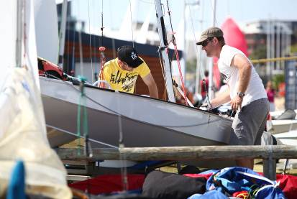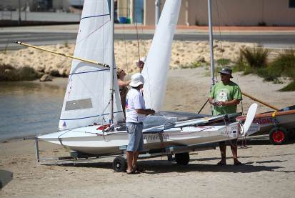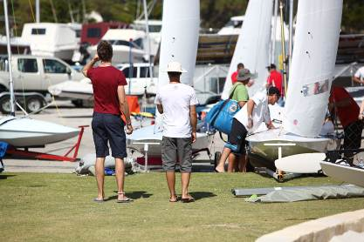
Economic Impact
Detail the economic impact from the visitor numbers of your event. If you did not conduct formal research to measure economic impact please provide an estimate and please provide an explanation of how you have estimated these figures.
Table 2: Economic Impact
 | Intrastate visitors | Interstate visitors | International visitors | Total visitors
Visiting the town/area specifically for the event | 55 | 130 | 110 | 305
Extending stay due to the event

Average daily spend  (accommodation, meals, entertainment, etc) | $230 | $260 | $260
Length of Stay | 16 | 18 | 21
Direct expenditure $ | $202,400 | $608,400 | 600,600 | $1,411,400

Number of days stayed is based on survey of attendees.
Average daily spend is based around –
3 meals per day $ 70.00
Average accommodation rate of $120.00 to $140per person per night
Drinks after sailing $ 20.00
Social $ 20.00

Based on information received from attendees –
People ate out in a restaurant or café 80% of evenings and cooked 20%
Lunch was purchased most days either at a café or at the sailing club
People attended the hotels on average 8 nights of their trip
Families utilised the cinema, bowling, zoo etc. at least 4 times during their stay
80% of people used the lay days to explore the local surrounds with Fremantle being the most popular location.
Marketing and Promotions
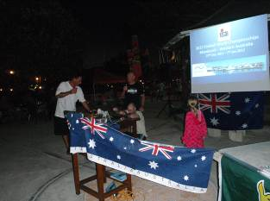
- Power point presentation with free Vegemite sandwiches and beer at the 2010 Fireball Worlds in Barbados.
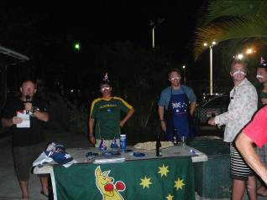
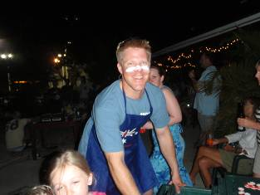

- Official launch of 2012 Fireball Worlds at MOFSC in June 2010 with Honourable Dr Kim Hames making the announcement in front of local media.
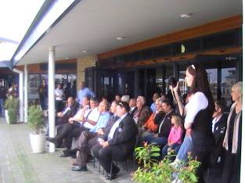
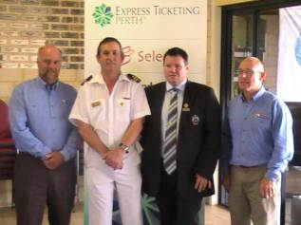
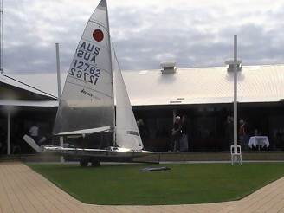

- Power point presentation with 2 course dinner at the 2011 Fireball Worlds in Ireland.
- Dedicated section of Fireball Australia web site with information on the venue and the event from 2009 onwards. This included details on the area, accommodation, climate, things to see and do, etc.
- T shirts produced and distributed to class representatives around the world 12 months prior to event.
- Stickers produced and distributed to class representatives around the world 8 months prior to event.
- Wrist bands produced and distributed to class representatives around the world 6 months prior to event.
- Facebook group and page established to get information out to the younger community.
- Letter drop to over 500 local businesses.
- Visits to key local businesses with information packs promoting the championships and benefits to the community.
- Three large cloth banners used to promote the event at other sailing events.

- Two large PVC banners, one placed in the main street of Mandurah and one at MOFSC.
- 1000 A3 posters printed and distributed to sailing clubs around the globe.
- 10 A1 posters printed for the event, displayed in local businesses.
- Articles in local newspapers – see attached.
- Interviews on local radio – see attached.
- Numerous articles and pictures on International sailing web sites.
- 5 Association owned Fireballs sent over to Mandurah over a two year period to help build a fleet. All ended up privately owned and sailing in the world championships as well as another 5 being purchased privately as a result. Note this has been one of the most successful fleet developments of Fireballs worldwide and will form the model for future growth of the class.

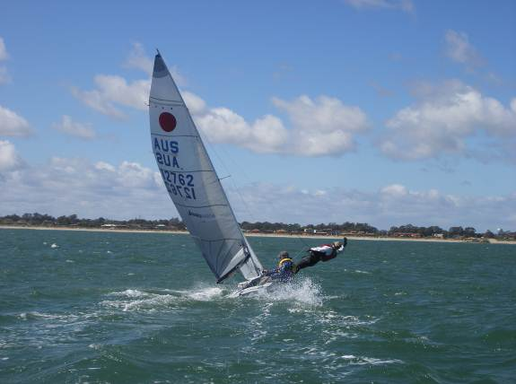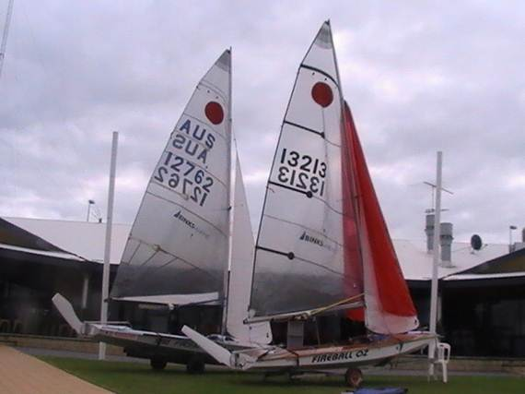

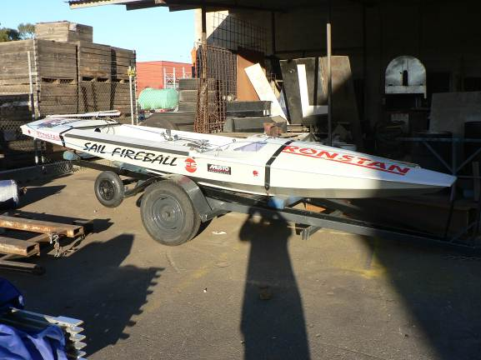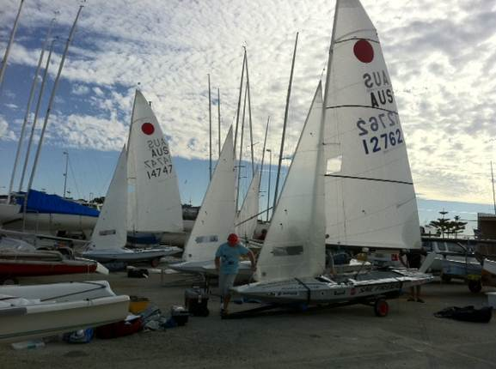
Media Impact
Event publicity officer Johno Fullerton was in charge of writing daily race reports and distributing them to the media. He also gave live updates from on the water in interviews with Coastal FM and twittered live updates that flowed through to the Fireball Australia web site and on to the event Facebook Page. Below is a brief summary of where Johno sent information.
Daily Race Reports:
Yachts & Yachting www.yachtsandyachting.com
Sail-World www.sail-world.com
Daily Sail www.thedailysail.com
Grand Prix Sailing www.gpsailing.org

Updates
ISAF International Sailing Federation www.sailing.org
Sailing World US www.sailingworld.com
Bulkhead Magazine in Japan www.bulkhead.sblo.jp
Scuttlebutt website www.scuttlebutt.com
Australian Sailing website mysailing.com.au
Fotoboat website www.fotoboat.com
Pinnell & Bax newsletter

Post regatta article
Australian Sailing (March issue)
Yachts and Yachting (March issue)

Fireball Associations
Fireball Australia
UK Fireball Association
Canadian Fireball Association
Czech Fireball Association
Swiss Fireball Association
Japanese Fireball Association

Television
Local Sunrise show

Radio
Live Coastal FM updates from the water

Video
Boats on TV
World on Water
Tom Gruitts video on fotoboat.com and facebook

Photos:
Fotoboat website www.fotoboat.com
Daily photo update on the MOFSC screen

Sent to:
Yachting Australia
Yachting WA
Yachting SA
Yachting Victoria

Newspapers etc:
West Australian
The West.com.au
Mandurah Coastal Times
Sound Telegraph.com.au
Community News

Date | Media | Type | Page Ref | Title
23/06/2010 | Mandurah Coastal Times | Newspaper | - | Fireballs heading to Mandurah
23/06/2010 | - | Newspaper | - | Mandurah prepares for sailing event
16/06/2011 | The Mandurah Mail | Newspaper | 107 | Winter series underway
20/10/2011 | The Mandurah Mail | Newspaper | 108 | Fireball comes to the foreshore
2/11/2011 | Yachtng WA | Website | - | Fireball Worlds update
3/11/2011 | Department of Sport & Recreation | Website | - | Mandurah's first world sailing championship approaching
1/12/2011 | The Mandurah Mail | Newspaper | 106 | World championships arriving in Peel
22/12/2011 | The Mandurah Mail | Newspaper | 97 | First International Championship
22/12/2011 | The Mandurah Mail | Newspaper | 98 | Local champion takes on the world
5/01/2012 | The Mandurah Mail | Newspaper | 84 | Peel on the world stage for siling
5/01/2012 | The Mandurah Mail | Newspaper | 84 | International Fireball Championships - Difficult seas shorten warm-up event
5/01/2012 | The Mandurah Mail | Newspaper | 85 | International Fireball Championships - Official Opening
11/01/2012 | Mandurah Coastal Times | Newspaper | Front | Sailors turn up heat
11/01/2012 | Mandurah Coastal Times | Newspaper | 3 | Gail lured by her Fireball
11/01/2012 | Mandurah Coastal Times | Newspaper | 32&33 | British duo on fire
12/01/2012 | The Mandurah Mail | Newspaper | 112-113 | Great Britain breeze ahead of Australians in Championships
18/01/2012 | Yachting WA | Electronic Newsletter | 12 | WA Sailors Jump Aboard to Embrace Fireball World Championships
19/01/2012 | The Mandurah Mail | Newspaper | 102 | Passion alight for sailing enthusiast

Social Media
Facebook
Twitter

NB: This is only content we have seen or has been promised, many other websites and print media have been sent daily releases
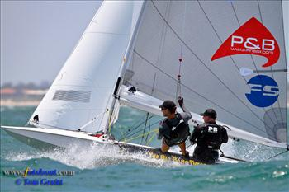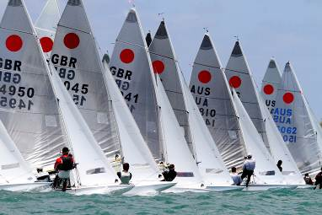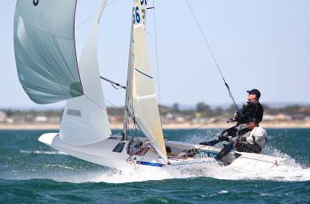
Sponsorship
Government funding through grants –
- Eventscorp $15,000
- Royalties for Regions $30,000
- Department of Sport and Recreation $ 8,000
- Mandurah City Council $ 9,000
Total $62,000

Private Sector funding –
  - Zhik (In Kind) $ 8,000
  - Ronstan (In Kind) $ 2,000
  - Bowley Plumbing $ 1,000
  - Fletcher Sailing (In Kind) $ 600
  - John Clifton Sails (In Kind) $ 600
  - Tayper International (In Kind) $ 1,500
  - Hertz Mandurah (In Kind) $ 800
  - Fantastic Sailing Trophies (In Kind) $ 500
  - Malaysian Airlines (In Kind) $ 1,000
  - Perth 2011 (In Kind) $ 5,000
Total $21,000

Note the in kind sponsorship is not included in the financials as it was for product and no invoice issued.

Private cash funding was hard to attract in the current economic climate. Over 500 letters were sent to local, state and national businesses with a sponsorship pack included whi9ch provided a number or sponsorship packages to suit their needs. Two weeks after the letters went out, a follow up phone call was made to each business. In the majority of cases the answer was a straight forward “not in this economic climate”. In the cases where there was interest expressed follow up phone calls and meetings were arranged. While a number of businesses of varying sizes expressed interest in getting involved, very few were prepared to commit at the crunch time.

Following on from this it was decided that a change of approach was required. Firstly a fund raising dinner was arranged with Jessica Watson as the guest speaker. This was well supported by the media and local sporting clubs who donated items to be auctioned off during the evening. The event sold to 70% capacity and generated approximately $2000 towards the event.

Next a raffle was arranged with tickets sold nationally. Prizes were either donated or purchased at costs well below retail. Approximately 1000 tickets were sold bringing in $3300 after costs.

Businesses were happier to offer “In Kind” support rather than cash. Zhik offered sailing clothing for free as race prizes and discounted regatta “T-shirts”, others offered product as prizes and some provided discounts on purchases such as cheap flights, car hire and overall prizes.

It should be noted that more half of the costs of running the championships were covered by entry fees charged to participants.

Community Support
The event was well supported by the community.

Mandurah City Council held a Civic Reception to open the event. They were also very supportive through provision of funds to help with marketing, signage and security. The council was also able to lend support through advertising the event itself.

The Mandurah Visitor Centre helped with finding accommodation for interstate and overseas competitors. They also provided a range of options for local tours and things to do in and around the area, Each person who attended the event received a bag with a map and tourist brochures supplied by the visitor centre.

Peel Bus Charters were a great supporter of the event supplying a minibus and driver to transport competitors and their families around the local area, do airport pickups and drop-offs and also provided trips to Perth and Fremantle for shopping / sightseeing. They also ran trips on days where there wasn’t racing - a New Year’s Day Trip to a number of local wineries and brewery and a trip up to Perth and down the Swan River with Dinner in Fremantle on the 5th January.

Hertz Mandurah offered discounts on car hire to competitors and help out with vehicles for officials.

Players nightclub offered free entry to competitors during their stay.

Mandurah Ocean Marina Chalets and The Atrium provided discounted accommodation.

Australian Sailing Museum provided free admission passes to be given away as prizes.

Bouvard Cruises arranged for attendees to get out on the water and see the dolphins and the Christmas lights.

There were many more business that helped out where they could.

The local restaurants and hotels got behind the event also. All attendees were given a very visible wrist band to wear during the event which allowed them to be distinguished from the general public. Through this local businesses were able to identify them and make sure that visitors to the area were made to feel welcome.

The local media were also very supportive with both newspapers and the radio station happy to promote the event both before and during.

Attendance
The official opening ceremony for the event was held on the 28th December at MOFSC. An initial 30 minute closed function was held for dignitaries and guests where Mayor Patti Creevey spoke first followed by the Honourable Dr Kim Hames. From there dignitaries moved into the main function area where a cocktail party was held with all competitors, volunteers and their families in attendance. Unfortunately Kim Hames was unable to stay for this second part of the evening. Major Patti Creevy again spoke welcoming all visitors.
Those invited to attend the event included in no particular order-
Title | First Name | Surname | Position | Company
Ms | Joanne | Abbiss | CEO | Shire of Serpentine Jarrahdale
Mr | Mick | Bowley |  | Bowley Plumbing Services
Cr | Walley | Barrett | Shire President | Shire of Murray
Hon | Ian | Campbell | Chairman | Perth 2011
Cr | John | Allert | Shire President | Shire of Boddington
Mr | Stephen | Carter | Commodore | MOFSC
Mr | Tony | Claydon | CEO | Yachting WA
 | Ivan | Bullock |  | Fremantle Malls
 | Rose | Bullock
Mr | Steve | Coughlan | Board Member | C/- Peel Development Commission
Mr | Murray | Cowper | Member for Murray - Wellington
Mayor | Paddi | Creevey | Mayor | City of Mandurah
Mr | Peter | Crossley | Australian President | Fireball
Mr | Ian | Curley | CEO | Shire of Waroona
Mr | Andrew | Davies | World Secretary | Fireball
Mr | Timothy | Donkin | General Manager | MOFSC
Hon | Gary | Gray AO MP | Federal Member for Brand
Hon | Brendon | Grylls MLA | Minister for Regional Development; Lands; Minister Assisting the Minister for State Development, | Minister Assisting the Minister for Transport, Leader of the Parliamentary National Party (WA)
Hon Dr | Kim | Hames MLA | Deputy Premier; Minister for Health; Tourism
Mrs | Effira | Harlond | Branch Manager | Hertz Car Rental
Cr | Merri | Harris | Board Member | C/- Peel Development Commission
Mrs | Elizabeth | Hoek | Board Member | C/- Peel Development Commission
Mr | Geoff | Totterdell | Chairman | Peel Development Commission Office
Mr | Bob | Jackson | Vice Commodore | MOFSC
Mr | Mark | Jeffery | Board Member | C/- Peel Development Commission
Mrs | Pam | Johnson | Championship Measurer | Fireball International
Mr | Barry | Houghton
 | Lena | Houghton | PA to the Mayor | City of Mandurah
Mr | Doug | Kerr | President | Yachting WA
Mr | Patrick | Langley |  | Australian Zhik
Mr | John | Longley | Event Director | Perth 2011
Mr | Kevin | Luff | Chair Organising Committee | MOFSC
Mr | David | Malone | Executive Director | Healthways
Mr | Noel | Nancarrow | Board Member | C/- Peel Development Commission
Mr | Mark | Newman | Chief Executive Officer | City of Mandurah
 | Ros | Newman
Mrs | Sue | Olsen | Offwater/ Administrator | MOFSC
Mr | Robin | Olsen | Onwater PRO | MOFSC
Mr | Don | Randall MP | Federal Member for Canning
Mr | Andre | Raoult | Jury - Cook Islands
Mr | Mike | Rogers | Assistant Race Officer | Fireball
Mr | Mike | Ryan | Deputy Chairman | C/- Peel Development Commission
Mr | François | Schluchter | World President | Fireball International
Mr | Ben | Schulz | Australian Secretary | Fireball
Mr | Gary | Sherry | CEO | Shire of Boddington
Mr | Tony | Simpson | Member for Darling Range
Mr | Anthony | Stephen | Jury - Australian
Mr | Rut | Subniran | Jury - Thailand
Hon | Dr Sally | Talbot MLC | Member for the South West
Mr | David | Templeman | Member for Mandurah
Mr | Geoff | Totterdell | Chairman | C/- Peel Development Commission
Cr | Sheila | Twine | Shire President | Shire of Serpentine Jarrahdale
Mr | Dean | Unsworth | CEO | Shire of Murray
Hon | Terry | Waldron MLA | Member for Wagin | Shop 3, Narrogin Shopping Centre
Cr | Noel | Dew | Shire President | Shire of Waroona
Mr | Tim | Went | Jury - Australian
Cr | Rhys | Williams | Board Member | C/- Peel Development Commission
Ms | Colleen | Yates | A/CEO | Peel Development Commission
Hon | Nigel | Hallett MLC | Member for South West Region
Hon | Colin | Holt MLC | Member for South West Region | Shop 6, Wooditchup Centre
Hon | Barry | House MLC | Member for South West Region | Emilie Way and Aberdeen Street
Mr | Allan | Claydon | Director, Works and Services | City of Mandurah
Mr | Tony | Free | Director, Sustainable Development | City of Mandurah
Mr | Wido | Peppinck | Corporate Lawyer | City of Mandurah
Ms | Lesley | Wilkinson | Director, People & Communities | City of Mandurah
 | David | Coultas
Mr | Graeme | Davies | Executive Manager | City of Mandurah
 | Cr Lynn | Rodgers |  | City of Mandurah
 | Cr Darren | Lee |  | City of Mandurah
 | Cr Shane | Jones |  | City of Mandurah
 | Cr Gary | Brown |  | City of Mandurah
 | Merle | Brown |  | City of Mandruah
 | Cr Dave | Schumacher |  | City of Mandurah
 | Cr Marina | Vergone |  | City of Mandurah
 | Phil | Vergone
 | Cr Don | Pember |  | City of Mandurah
 | Cr Rhys | Williams |  | City of Mandurah
 | Hon Cr Fred | Riebeling |  | City of Mandurah
 | Cr Ron | Wortley |  | City of Mandurah
 | Cr Marion | Blair |  | City of Mandurah
 | Cr Caroline | Knight |  | City of Mandurah
 | Jane | Pole-Bell | Manager-Tourism & Business Support | City of Mandurah
 | Stewart | Pole-Bell |  | City of Mandurah
 | Simone | Warden |  | Cultivate Communications
 | Graeme | Warden
 | Amy | Paton | Event Development Assistant | EventsCorp WA
 | Ellyse | Paton. |  | EventsCorp WA
 | Franklyn | Nannup | Chairman | Winjan Aboriginal Corporation
 | Harry | Nannup | Elder | Binndjareb Tribe
Minister | Robyn | McSweeney

Major Patti Creevey also attended the Preworlds presentation dinner on 31st December and the Worlds presentation dinner on the 7th January, presenting the prizes.

Need some photos of the welcome night speeches here

Signage
The signage supplied was displayed in the main club rooms where the social functions were held and the nightly presentations made.

Signage when appropriate was also displayed outside the club house in the seating areas. This was the case New Year’s Eve when the Pre Worlds Presentations were made on the lawns in front of the club and also on the 3rd January when the nightly prize giving was done in the Hook Café seating area.

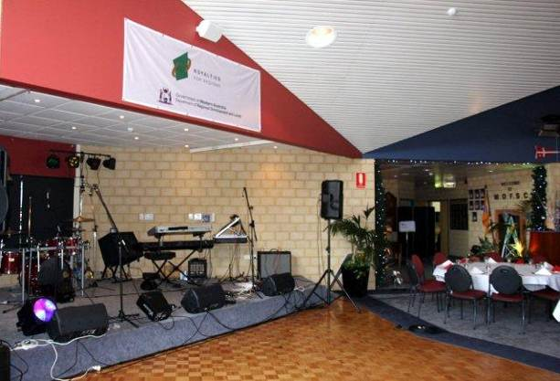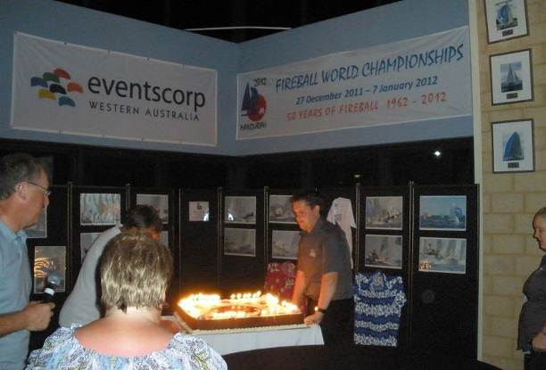

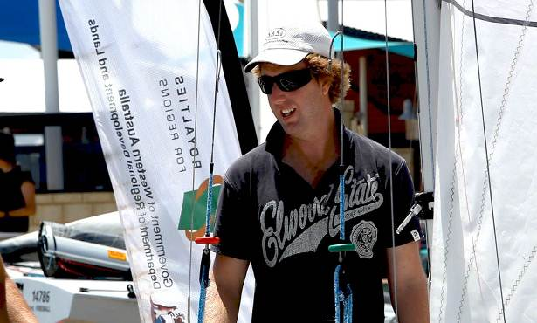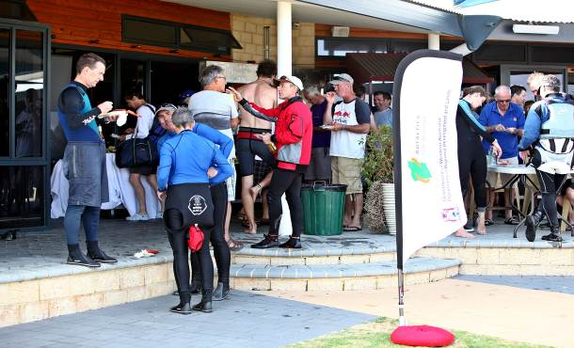

Any more if we have them
Welcome to Country - Kevin / MOFSC to Complete
A Welcome to Country ceremony was performed by Franklyn Nannup, Chairman of Winjan Aboriginal Corporation with traditional dances performed by Phillip Mears and Bindjareb Dance Group. The dances performed were …..

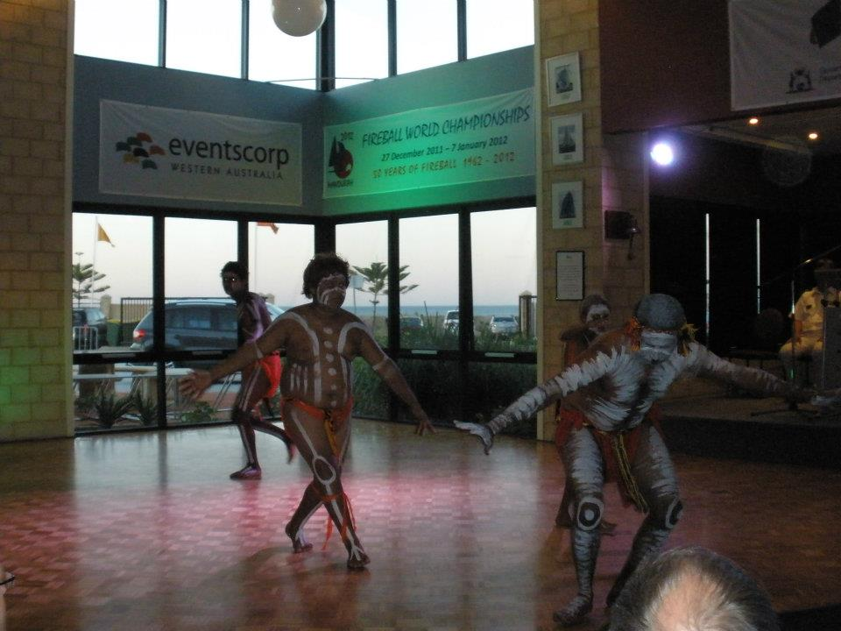

Event Budget
See attached audited financial statements.

Evaluation – Please add anything else necessary
The success of the event was measured using the following criteria –

- Attendance numbers,
- Financial success – ability to cover costs,
- Success of racing and race management,
- Success in staging social functions,
- Feedback from competitors, volunteers, non-sailors and public,

Attendance

With 64 boats, numbers were down on the target of 75. The number of Australian entries was as expected. The shortfall came in the numbers from overseas, particularly attendance from the United Kingdom, Canada and Ireland. Representatives from each of these countries stated that the lower attendance numbers from their region was not a reflection on the event but rather a result of the Global Financial Crisis. With a very strong Australian dollar, holidaying in Australia is the most expensive it has ever been. Couple this with poor economic conditions throughout much of the Western World, and it is understandable as to why numbers from these regions were down.

Bearing the economic factors in mind the event organisers were satisfied with the number of boats that entered.

While boat entries were down, the number of non-sailors who attended the event was higher than expected. This can be attributed to the extra emphasis on making the event one for both sailors and non-sailors. Publicity of the social side of the event and the great attractions Mandurah and WA had to offer paid off with strong support from those looking for a holiday.

All up attendance numbers at all off water functions was higher than expected.

Financial Success

Over the three years of planning, the budget has been adjusted to recognise the available income and put that income to best use. At the close of the accounts the event will have covered costs with a very small amount to spare – less than $100.00.

It is due to strong planning and budgeting along with different options available to best utilise funds that the organisers have been able to put on an event of the highest quality without over stretching the bank.

Again a success.

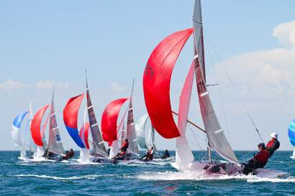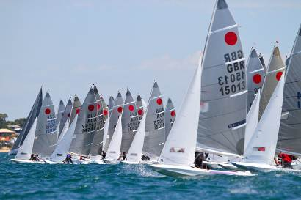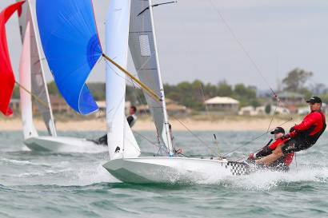

Successful Race Management

Robin Olsen and his team of volunteers did a great job under trying conditions to get all the races completed for the worlds. They remained steady in their decision making when under pressure from the weather and competitors and as a result put on ten exceptionally high quality races.

In sailing championships it is commonly accepted that losing a race is par for the course. It is always very tough to get all the races in when the weather often works against you.

Robin and his team were prepared for all conditions, continually adapting to what the weather offered.

Competitors were very happy with the way racing was conducted, particularly the ability of the race team to get races in as scheduled with great courses – allowing for some spectacular rides and tough racing.

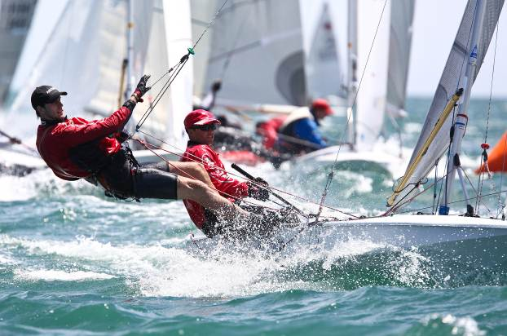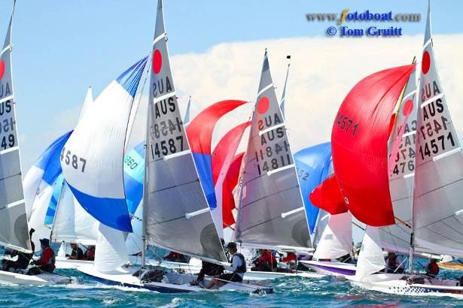

Successful Social Functions

Everyone expects great racing when attending a world championship. What sets an event above the rest is what happens off the water to make it memorable.

The 2008 World Championships in Thailand and the 2010 World Championships in Barbados are rated as the best events ever held. It was our aim to equal what was on offer at these events and then offer a bit more.

Four key social functions were scheduled –

- Welcome Night on the 27th December which was a Mayoral Reception with Welcome to Country Ceremony, a Welcome from the Honorable Dr Kim Hames and Mayor Patti Creevey and an official firing of the cannon to open the event. This was followed by a cocktail party with both hot and cold canapés. The evening was a chance for competitors to catch up with old friends and make new ones, setting the scene for the event.

- New Year’s Eve / Preworlds Presentation Dinner was a truly Australian affair. The event was run on the lawns in front of the club. An Aussie BBQ was laid on with steak, kangaroo, prawns and gourmet sausages. Prizes for the Australian Championships and the Pre- World Championships were presented by Mayor Patti Creevey. Following the presentations guests got down to welcoming in the new years with plenty of music, dancing and of course the fireworks.

- A party to celebrate the Fireball Class’ 50th Birthday was held on the 3rd January. It was a night to reminisce with the room decorated with t-shirts from 50 previous events and plenty of old memorabilia on display. A formal presentation was put on outlining the history of the class with some funny stories from class legends such as Mike Rogers and Gordon Lucas. A cake was brought out with Happy Birthday sung and the children in the room invited to blow out the candles, a symbol of the next generation of Fireball sailors.

- Worlds presentation evening was held on the 7th January with a sit down meal including a drinks package. Prizes were presented to the individual race winners, the top ten overall, the top three on handicap plus first senior, junior and female. Competitors spent the evening discussing the two week adventure they had just had, the near misses, the collisions, the good, the bad and the ugly. Everyone agreed that the event had been a huge success and they partied into the early hours of the morning.

In addition to these four functions nightly presentations were held with a happy hour, race prizes and lucky draws.

Meals were also available at the club each night other than public holidays.

All up the socials were a huge success. The food was excellent and the atmosphere great.

The free food and drink after sailing each day worked well in making people feel welcome and as a result people wanted to get involved in every function and help make the event fun and memorable.

In comparison to Barbados and Thailand the off water atmosphere was as good, if not better.

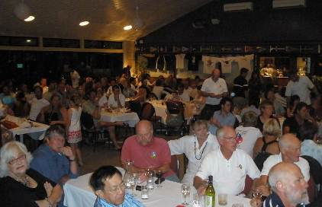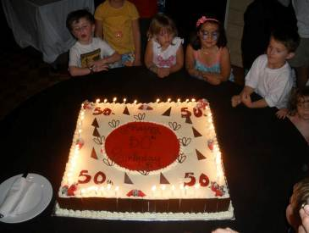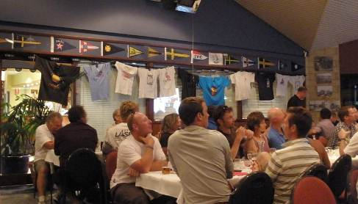

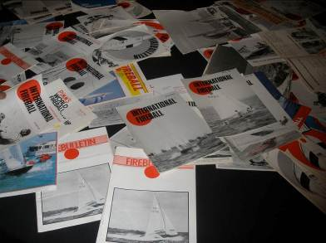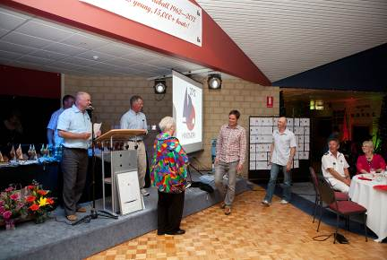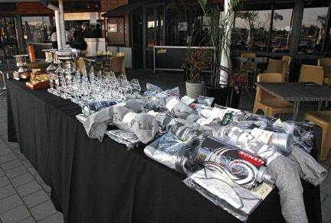

Feedback from Competitors

Throughout the event competitors, volunteers, non-sailors and the public were asked for their feedback. Any feedback was then acted on to make the event better.

Some of the feedback that led to changes included –

- Longer bar tracing on public holidays – addressed on the second day,
- Easier access to the club first thing in the morning – cleaners then opened up at 9am,
- Small questions which had answers on the main notice board but people weren’t looking there so a secondary larger board was assembled near the boat storage area.

Other than these most of the feedback was extremely positive –

- Many of the mums including Lyne Byrne from the UK and Alexis Martin from Melbourne heaped praise throughout the event as to how family focussed the event was. Items such as the sand pit, face painting and bouncy castles were things they had never encountered at a championship before and they were blown away by these small things.
- Competitors all express gratitude for having airport pickups and drop-offs provided – again a new idea.
- The mini bus was a big hit, particularly for the families wanting to explore the area.
- The Karcher pressure spray to wash the boats was admired with water usage and wash times cut by 80 %.
- The food and drink provided as sailors hit the beach after a hard day on the water was always gratefully received.

There were many more positives which lead to some great feedback on the event as a whole –

- Tom Egli (Fireball International Chairman) Rated the event in his top 3 ever, with Barbados and Thailand.
- Derian Scott from the UK said it was the best event she had ever been to – even better than Barbados.
- Hiroshi Kato from Japan thought the food and socials were amazing. Particularly all the fresh seafood.
- Richard and Lyne Byrne from the UK though a permanent move to Australia on the back of the event was something to seriously consider.
As a whole feedback from attendees was extremely positive. Most thought there was little we could have done better.
We walk away from the event sad that it is now over but also very proud that we put on a world class event that rivals the best of them.

Attachments –

- Audited Financial Accounts
- Event Program
- Event Poster
- Extract of Web Site
- Copies of Newspaper Articles
- Copies on Articles Published by Online Sailing Magazines
- Copy of Pre-world Championship Results
- Copy of World Championship Results

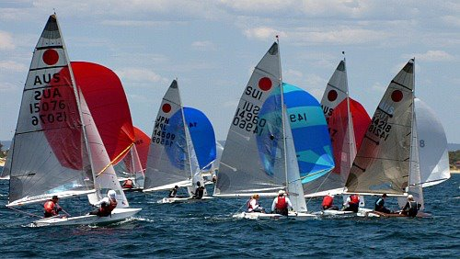

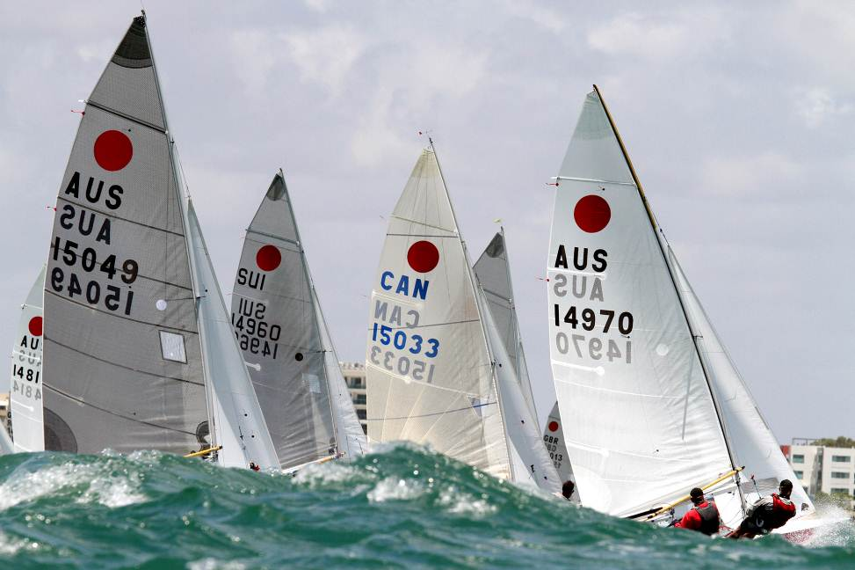
Other Photos –
